Setting up an Activity:
To register an activity or event with the Student Activities & Voice Team, ensure that you are logged into your student account on the Aston SU website. Navigate to the top right corner of the page and click on the settings icon, as you would to access your committee page. 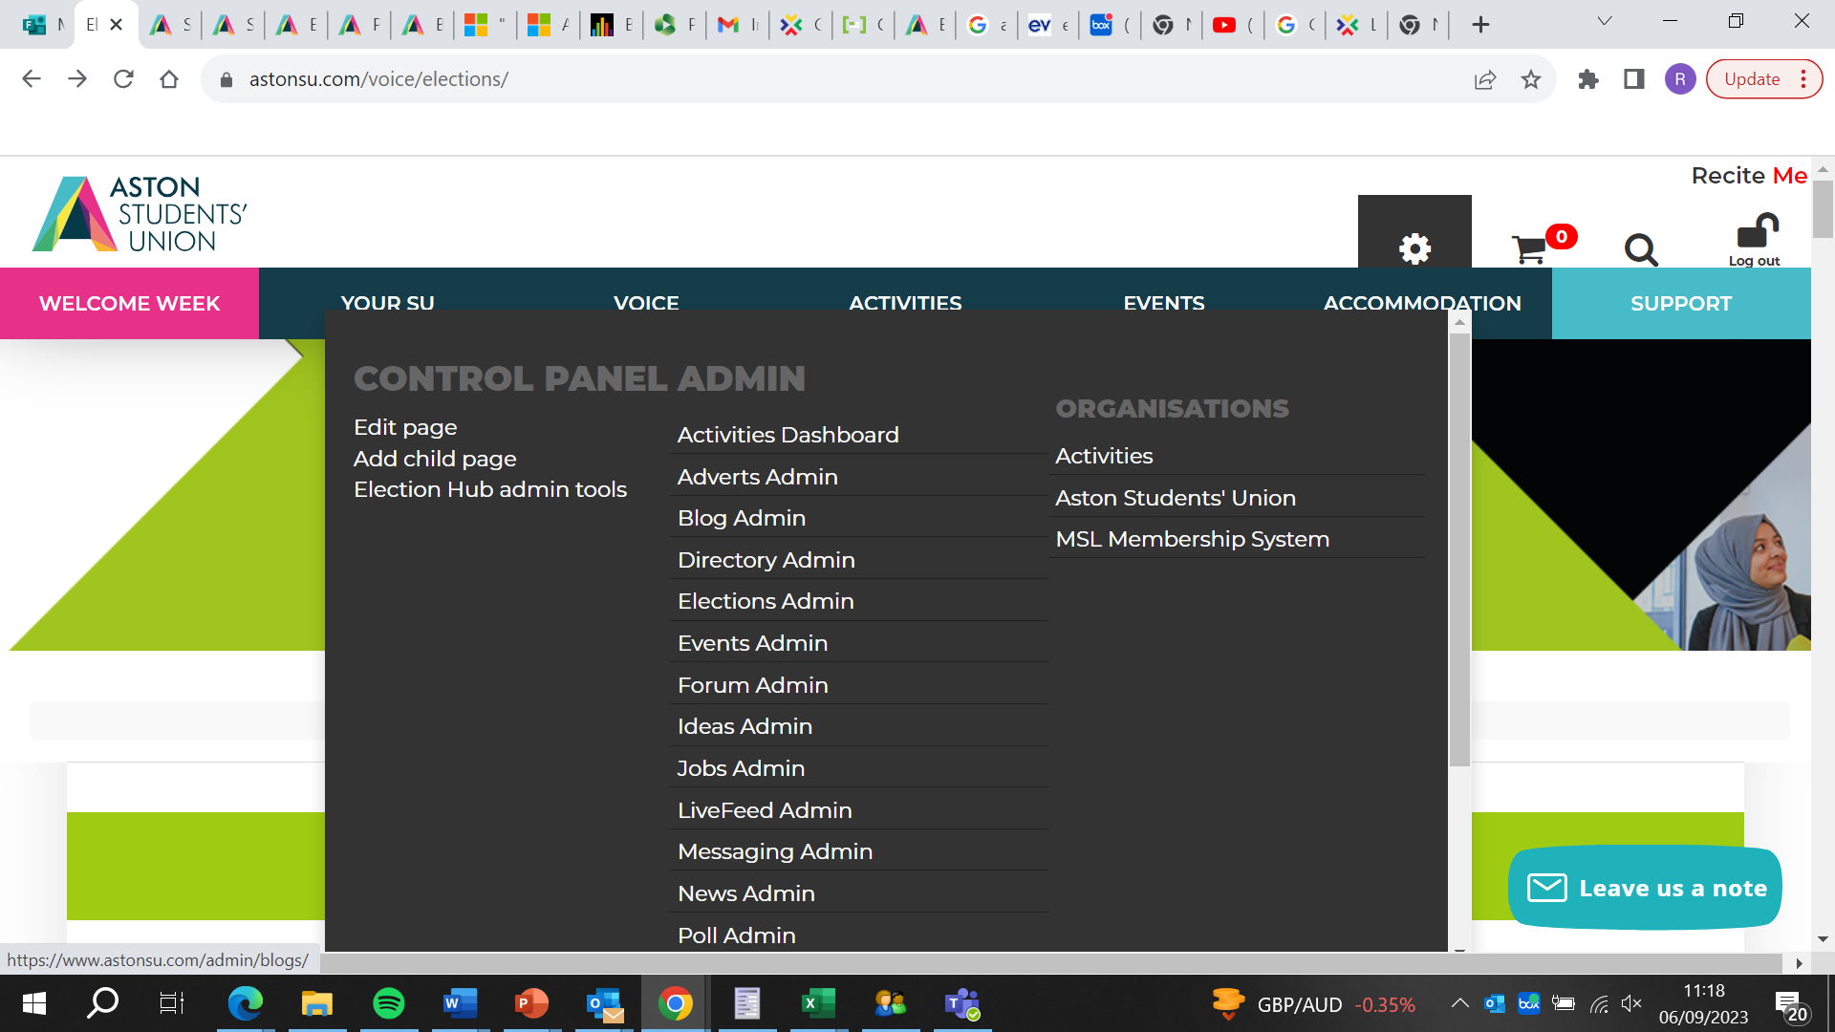
After accessing the Activities Dashboard, continue by clicking on "Activities." It's crucial to note that you should avoid clicking on "Events" at this stage.
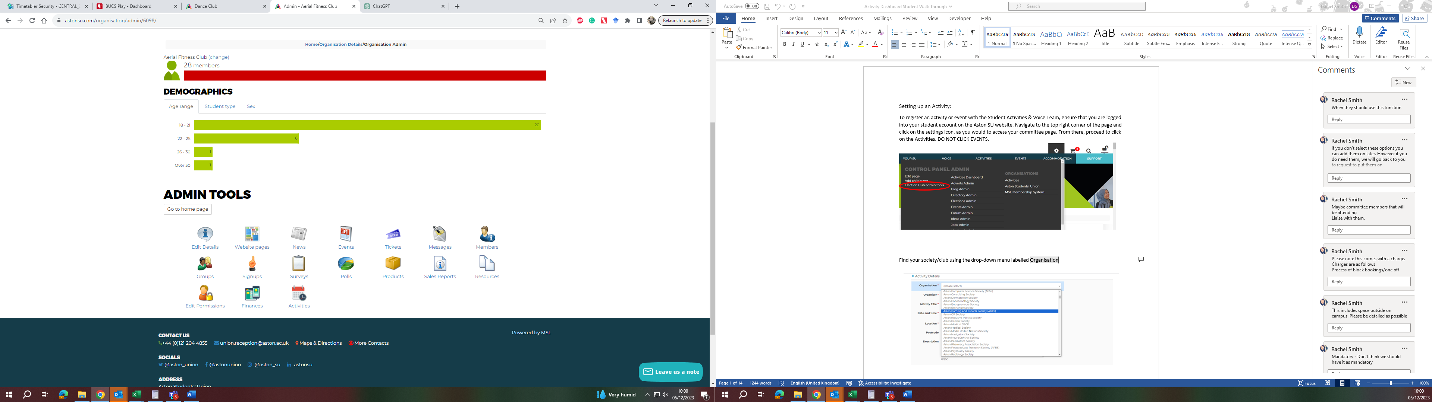
After accessing the Activities Dashboard, proceed by clicking on "All Activities." This page not only displays the events hosted by the admins for their own clubs or societies but also provides an option to create a new event or activity.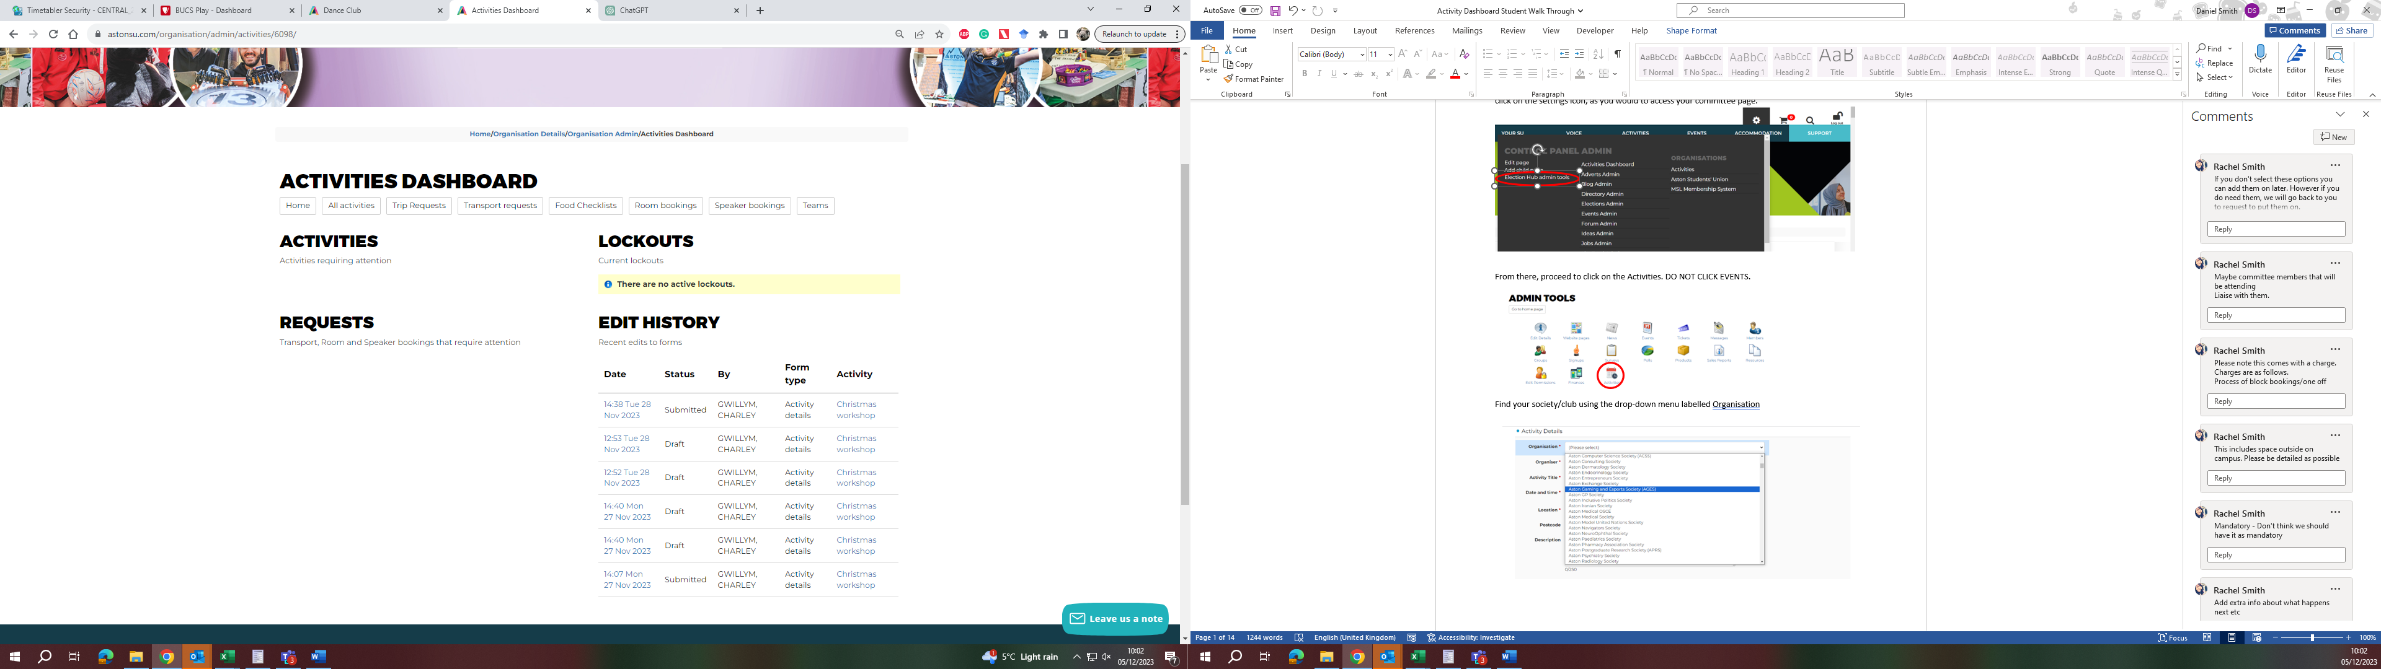

Following that, locate and click on the green button labelled "New Activity." This action will enable you to initiate the process of creating a new event.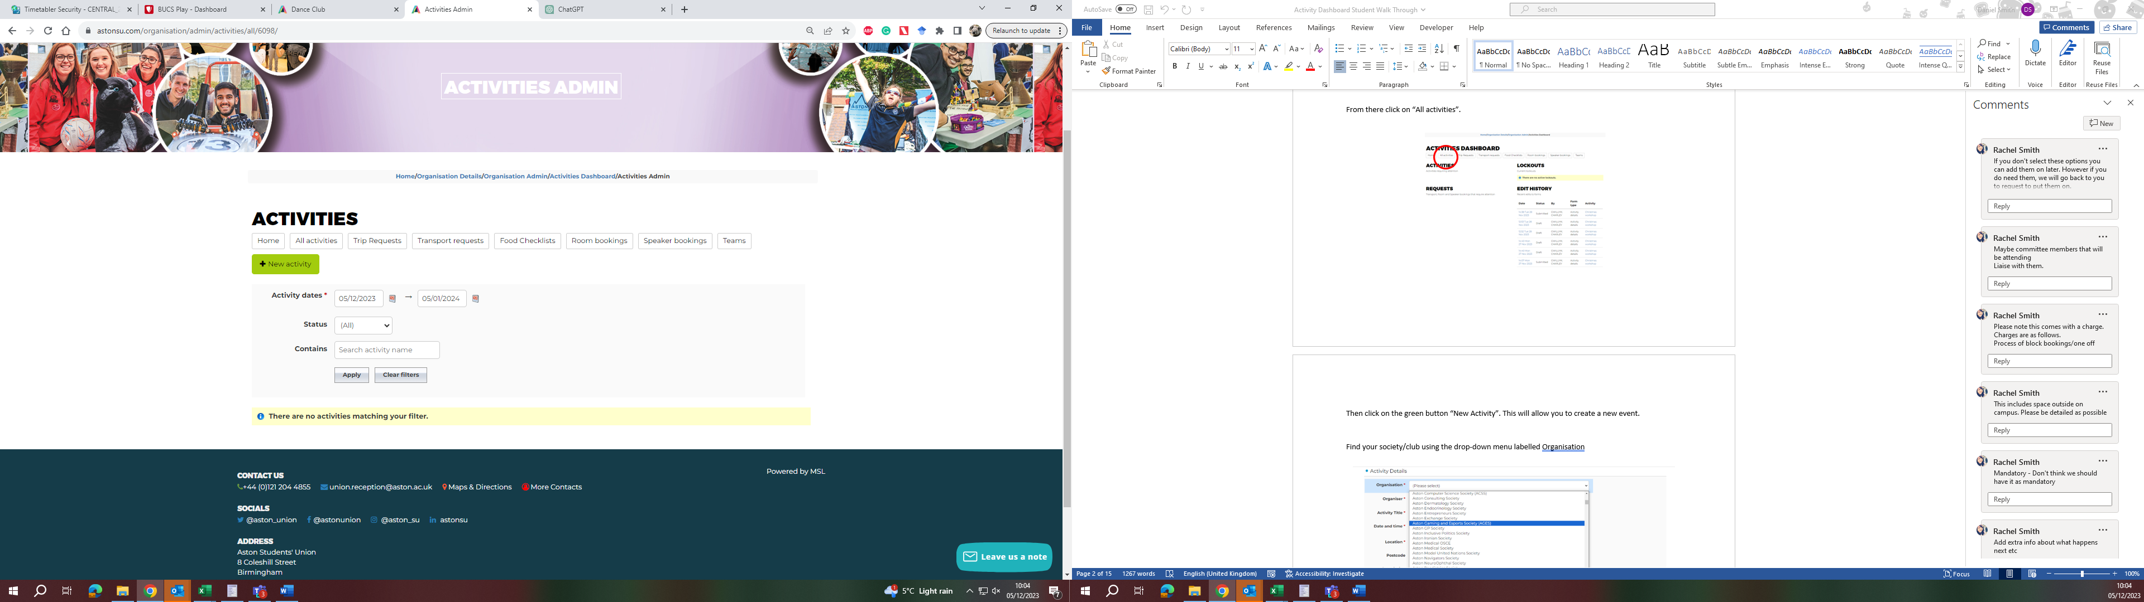
Locate your society or club by using the drop-down menu labelled "Organisation." Select your specific group from the list provided.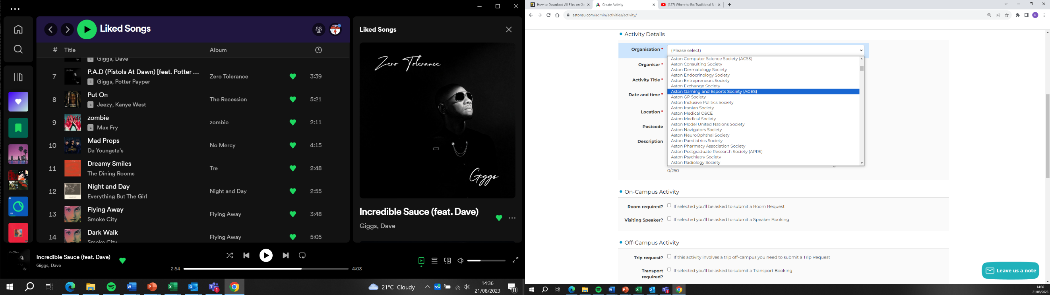

Select the name of the committee member who is the lead organizer for the event from the drop-down menu labelled "Organiser."
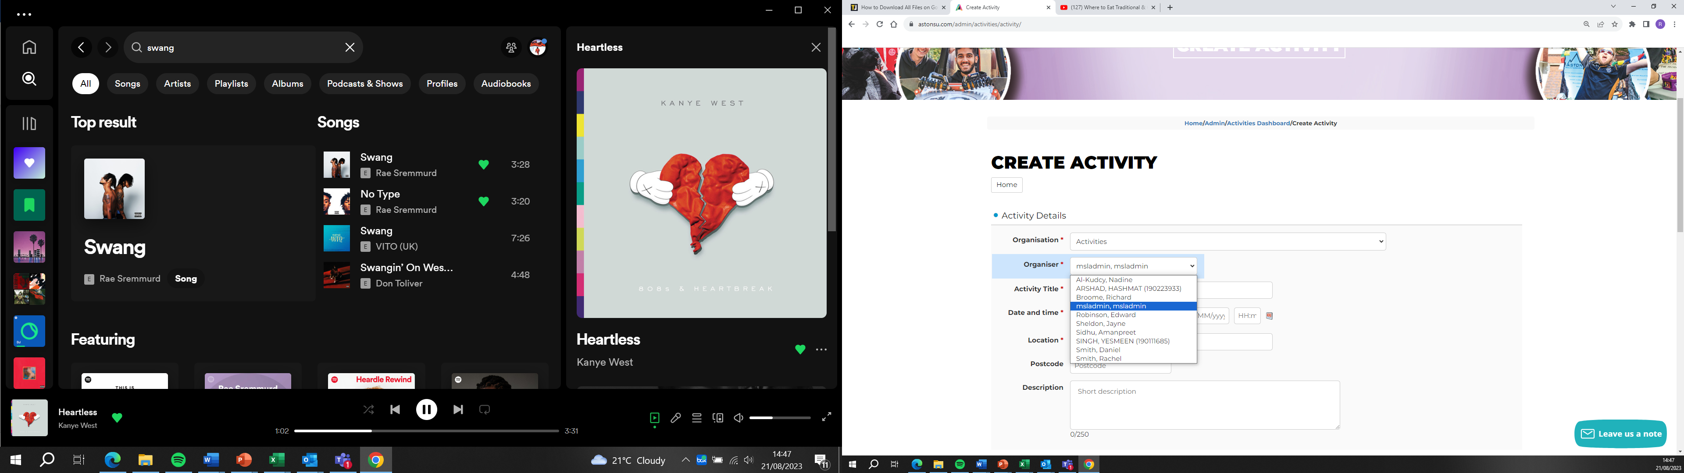

In this section, enter essential details for your event, including the event title, date, start and end times, and the location (preferably with a postcode). Additionally, it is highly recommended to provide a concise yet informative description of the event. Ensuring clarity in the description is crucial for efficient approval, as a clear understanding of the event is essential for the approval process. 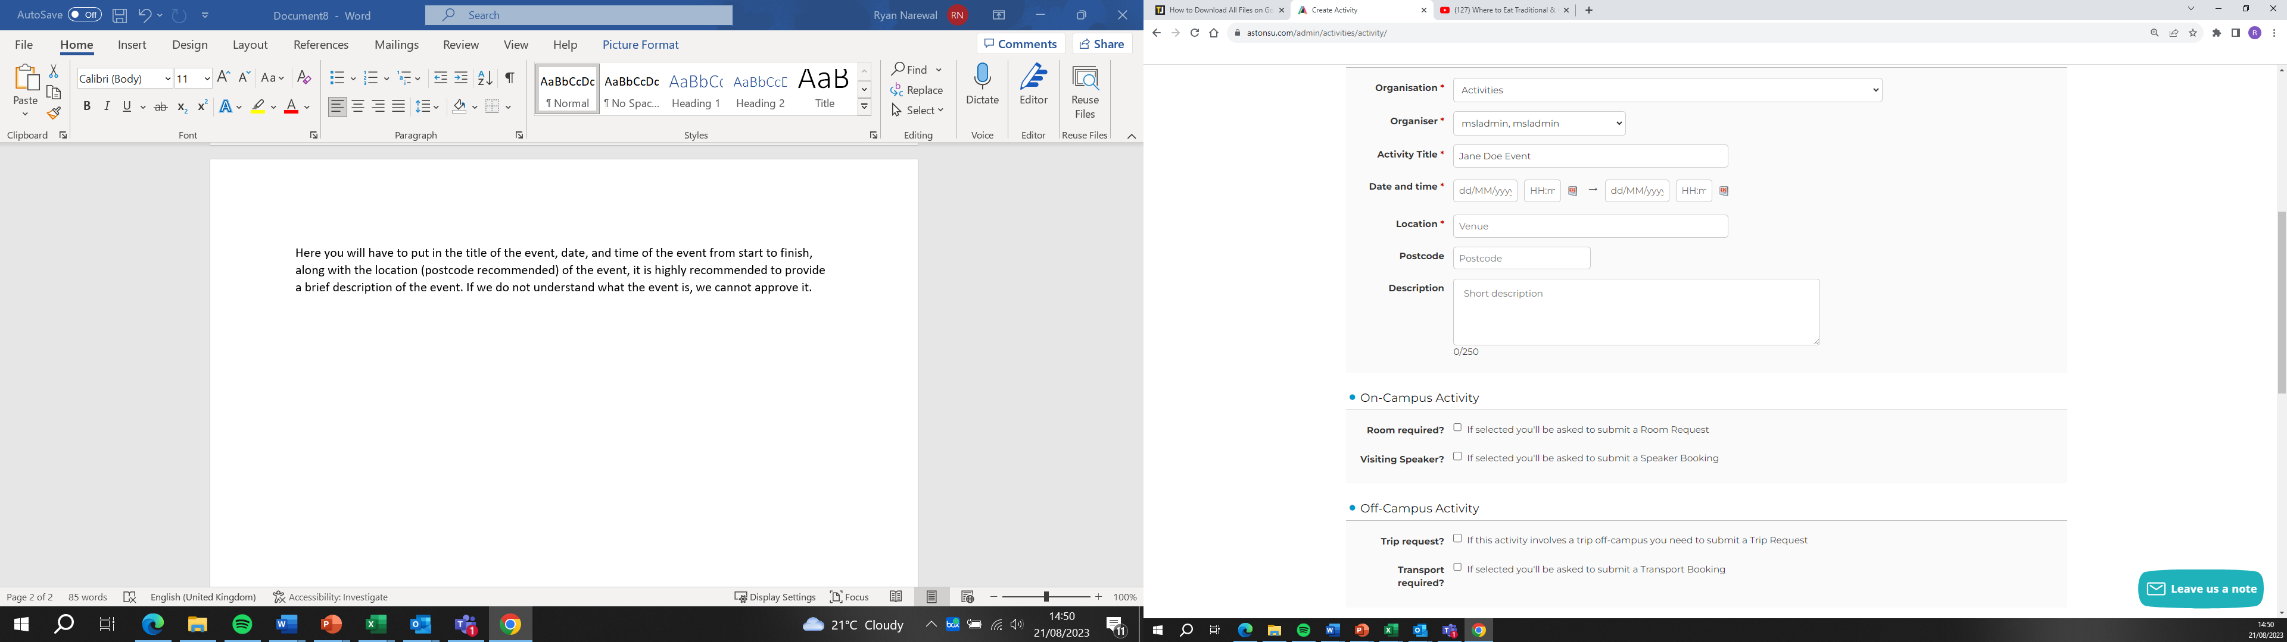

Choose the event date by clicking on the calendar icon. Ensure that you input the time in the 24-hour format for accuracy.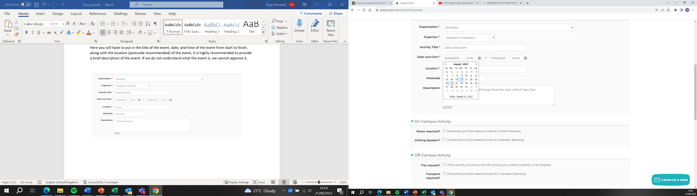

Provide a detailed and specific location for the event, including all pertinent details. Include information about the cost of the event and any potential safety hazards. This ensures transparency and helps in assessing the event's viability while addressing safety concerns. 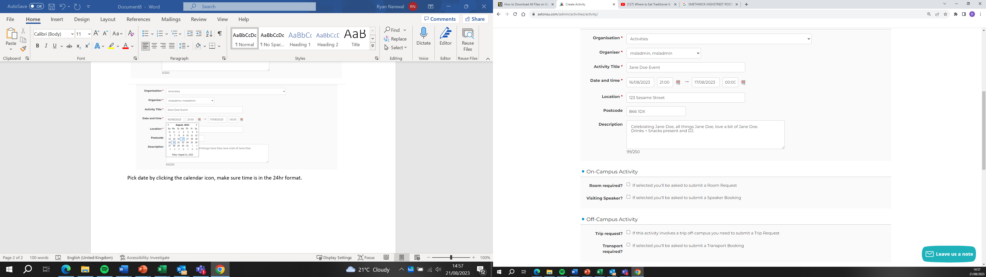

To ensure all logistical aspects are addressed, follow these guidelines:
- If a room within the SU or Main building is needed, tick the "Room Required" box.
- For events hosting external speakers (non-Aston students/staff), tick the "Visiting Speaker" box.
- If the event takes place off-campus, mark the "Trip Request" box.
- Tick the "Transport Required" box if transportation is needed. 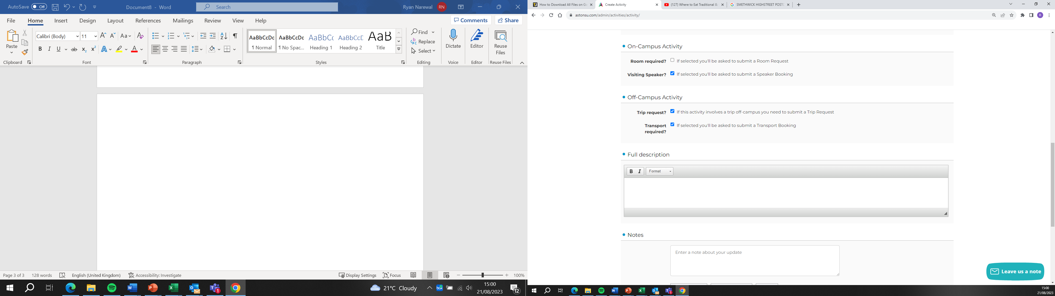
- You can choose to add these details later, but our team will contact you if they become necessary. Allocate sufficient time to accurately complete all requirements, fostering a proactive approach to streamline the approval process and avoid delays.
If none of the options in this section apply to your event, you can simply skip this section and proceed. However, if you wish to select any of the options (room requirement, visiting speaker, trip request, or transport), ensure that you have allowed sufficient time to fulfil the associated requirements. It's crucial to plan and allocate the necessary time to complete all requirements thoroughly and accurately. This proactive approach will contribute to a smoother process and help avoid any potential delays.

In this section, provide a comprehensive overview of your event, including a detailed timeline outlining how it will unfold. Specify the expected number of attendees, distinguishing between Aston and non-Aston participants.
Outline the details of the food and drinks to be served, along with any other pertinent and relevant information. Additionally, utilize the notes section to document any updates or changes made to the event after its initial submission. This ensures clarity and keeps all relevant information readily accessible for the organisers and approvers.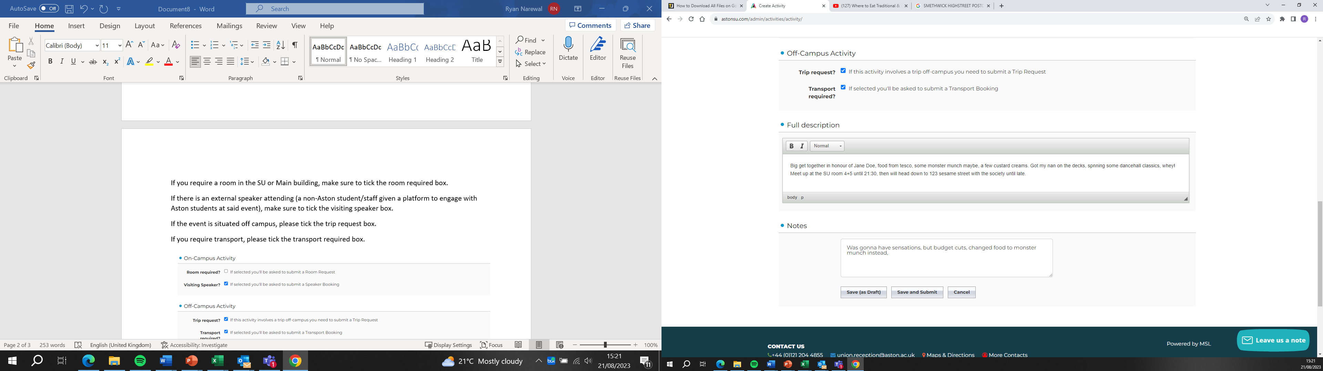

After submitting the event, you will be redirected to the forms page. Here, you are required to fill out the forms corresponding to the options you selected in the activity submission page. Ensure you complete the necessary forms accurately to provide additional details associated with the selected options. This step is essential for comprehensive event planning and approval.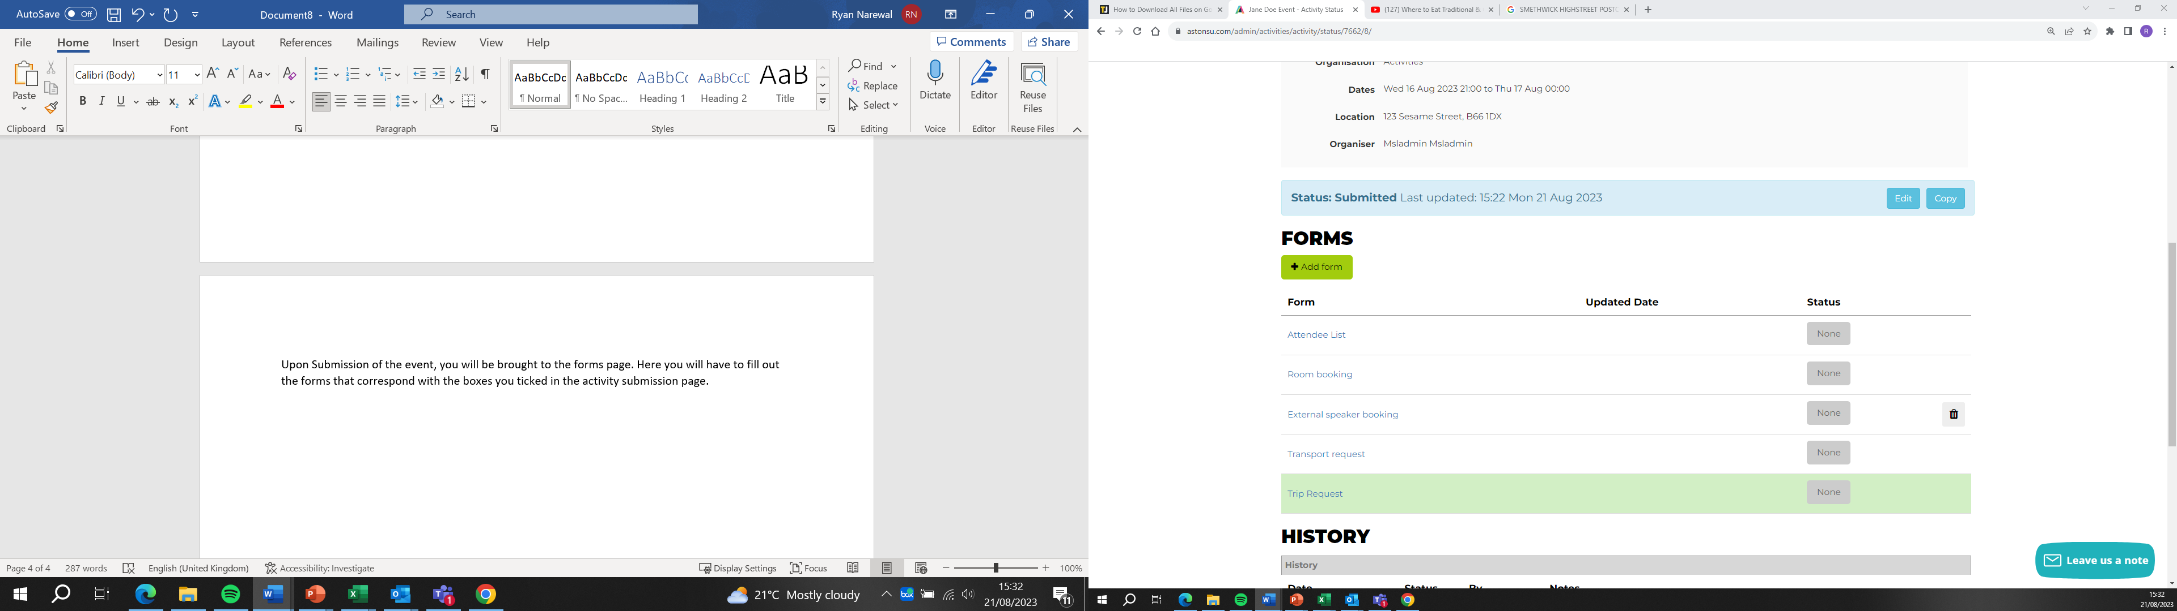

Attendees List:
For the Attendees List, it is mandatory to provide details of committee members attending the event. Clearly highlight which members from your committee will be present. Additionally, include specific details such as whether they are registered to drive SU vehicles and if they possess first aid qualifications. This information is crucial for logistical and safety considerations during the event.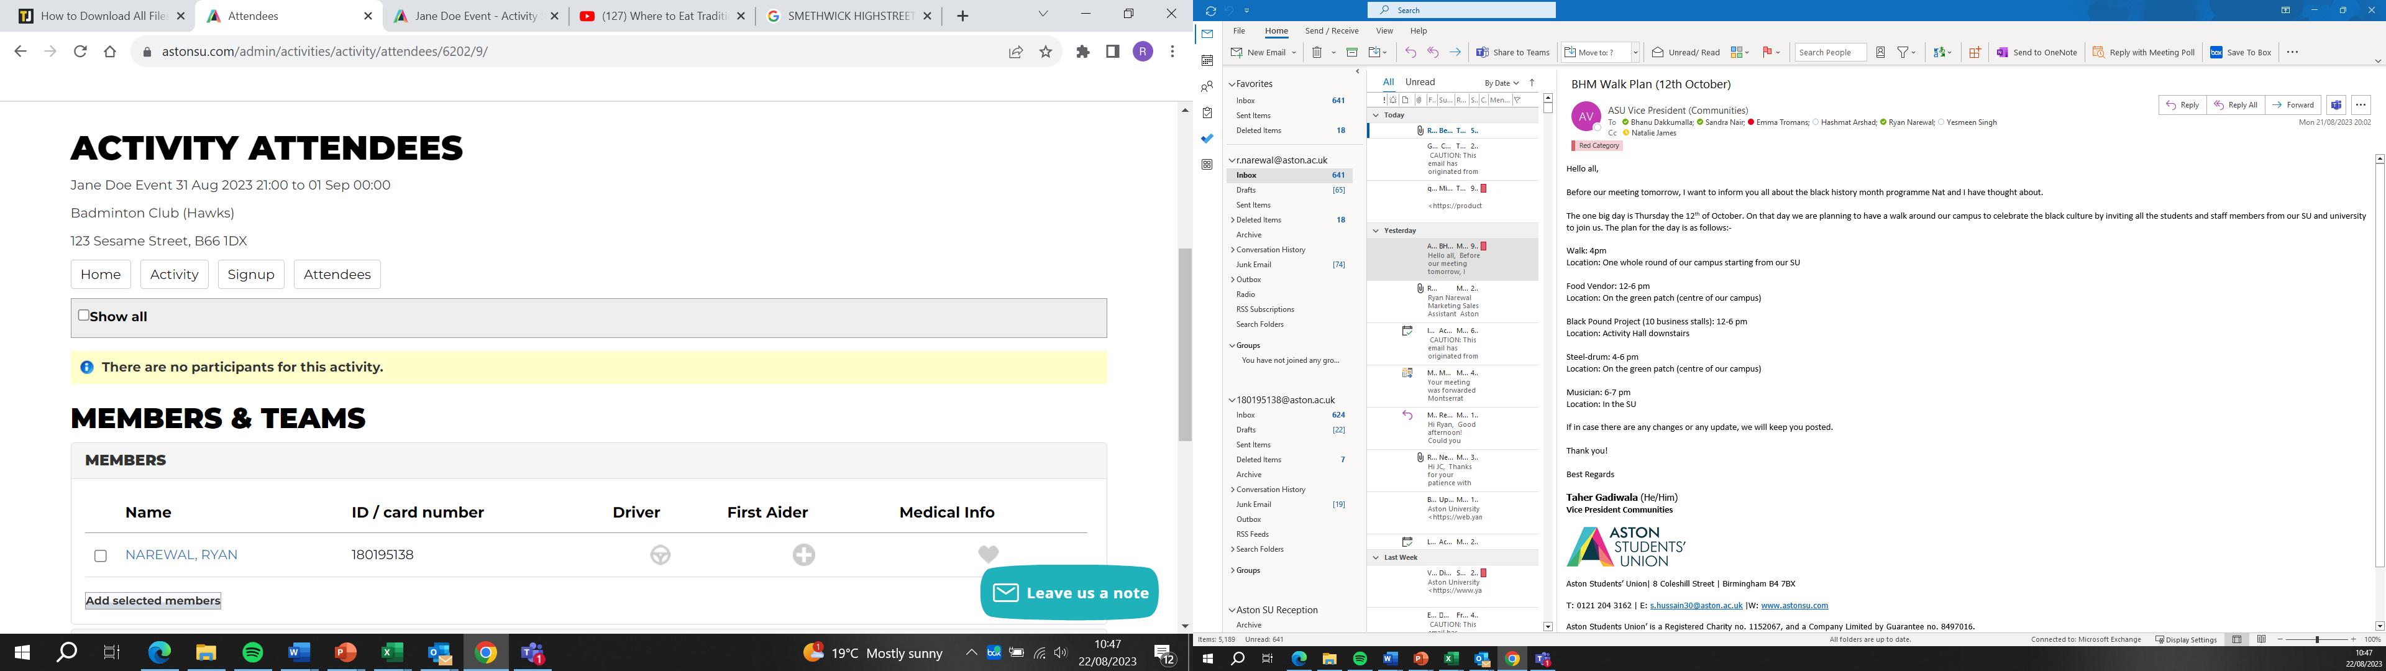

Following the submission of attendees, you have the option to manage their status. You can indicate whether an attendee has been disqualified, withdrawn from the event, or successfully signed up for the activity. This flexibility allows for dynamic adjustments and ensures that the attendee list accurately reflects the status of participants.
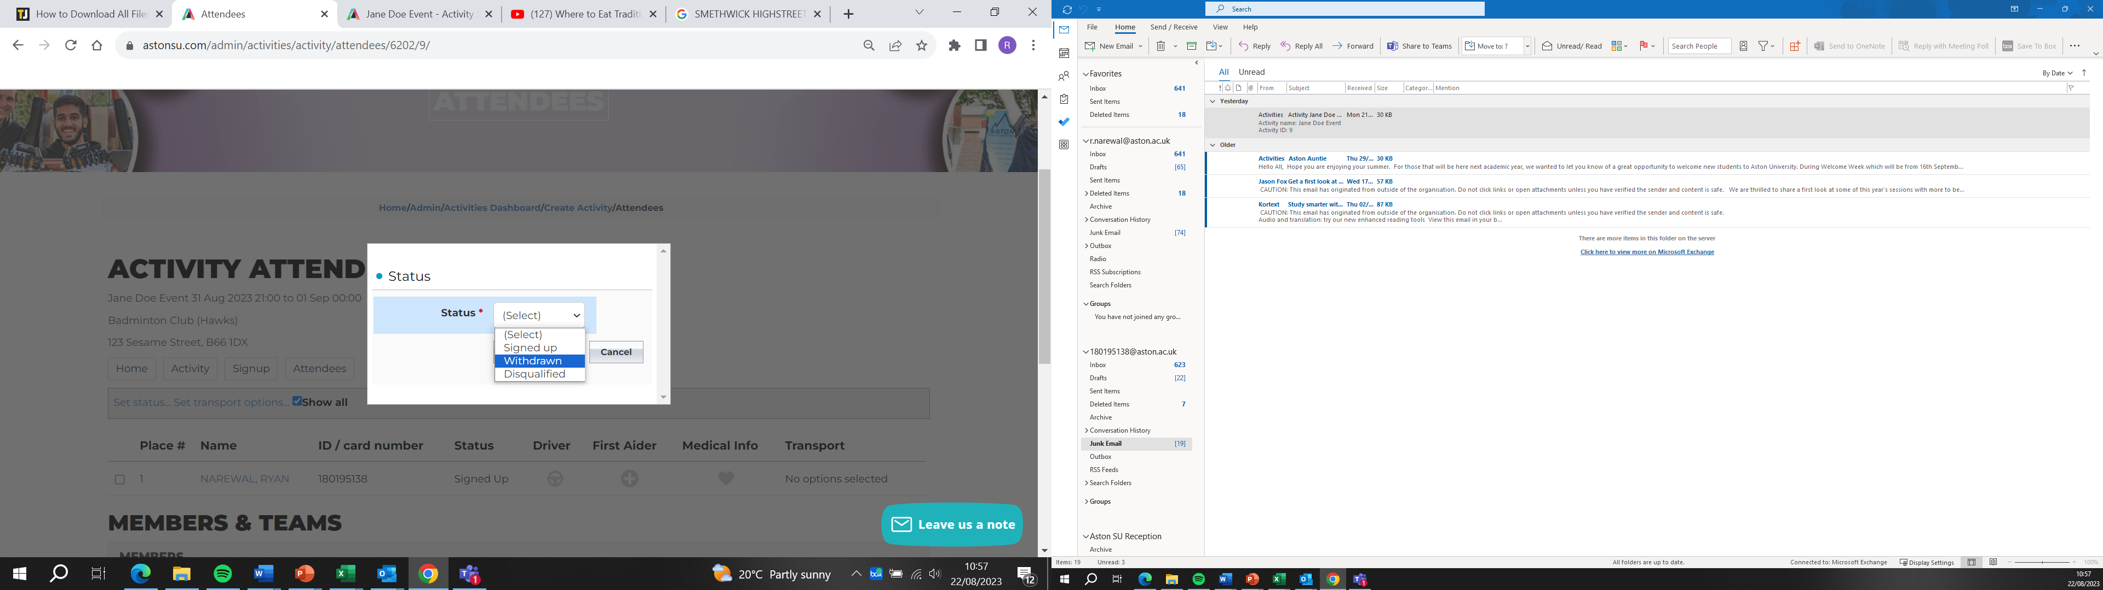

Room Booking Form:
The Room Booking form requires you to specify the desired room along with any specific requests for the space.
If booking an SU room, tick the corresponding rooms you wish to reserve. Indicate whether you require tables and chairs and provide details on the furniture layout.
Additionally, select any necessary equipment you'd like to have in the room for your event.
In the text box, provide specific details for any additional requests or specifications. Depending on the timing of your request, we will make every effort to accommodate your preferences.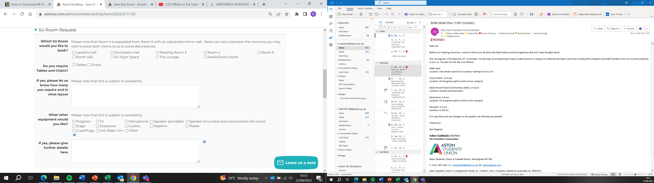

Select the specific room you'd like to book in the University by referring to the available space guide. If the preferred room is unavailable, we will try to accommodate you in a similar space, such as a lecture theatre or seminar room. The goal is to provide you with a suitable alternative that aligns with your event needs.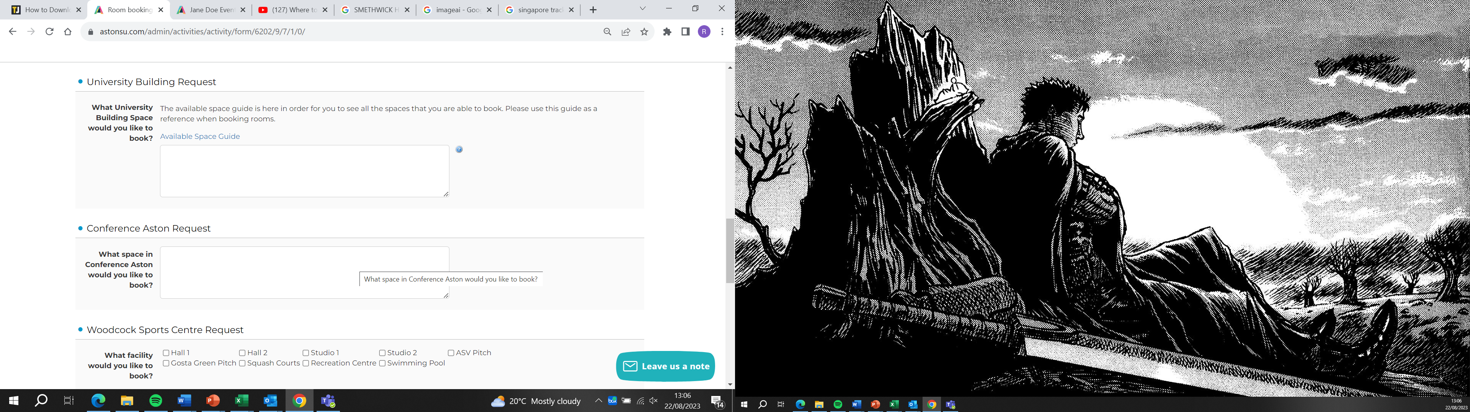

When booking space in the sports centre, please tick the specific area you wish to hire. It's important to note that all sports centre bookings come with a charge. For details on the charges, kindly consult with SA staff.
Additionally, there are specific processes for booking sports facilities. This process must go through a coordinator, as the sports facilities will not allow your club or society to book it independently. Ensure you liaise with the coordinator to navigate the booking process successfully.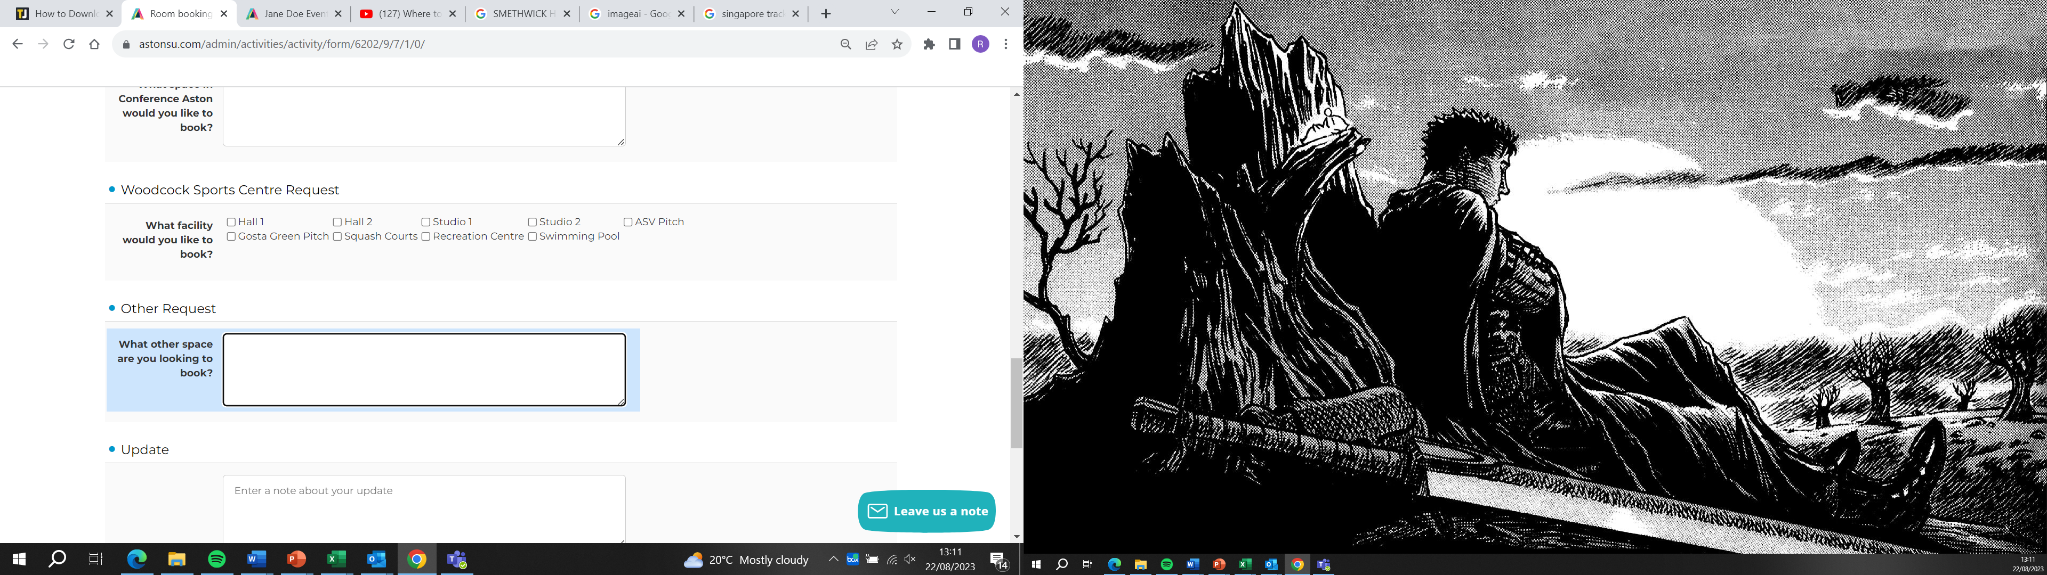
Here you can request to book a space that has not been listed as an option. These include spaces outside the campus, such as the Aston Recreational Centre.
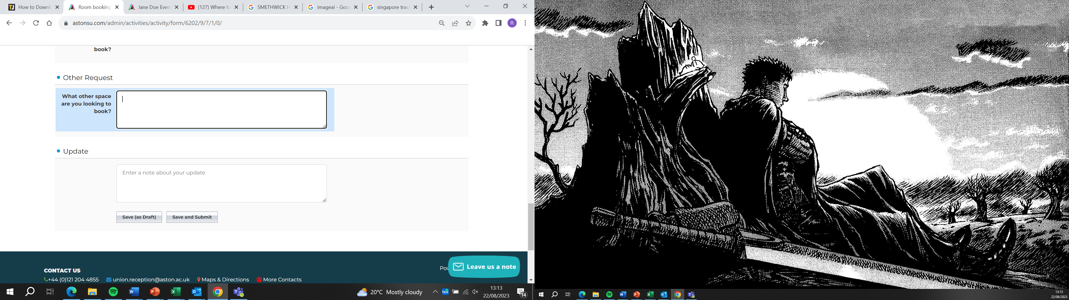

External Speaker Form:
When providing details about the external speaker, it is essential to include as much information as possible. The minimum requirements include:
1. Full Name of the speaker.
2. The organization they are affiliated with (if applicable; use "N/A" if independent).
3. Address, which can be either their personal address or the official address of the organization they represent, including spaces outside on campus.
4. Email address for communication purposes.
5. Topics the speaker will be discussing during the event.
6. Date of birth (recommended for security checks).
These details are necessary to conduct a security check on the individual. The more information provided, the faster the approval process. Once the background check is completed, the coordinator will contact you to confirm the approval of the external speaker. If you do not receive confirmation, it is advisable to follow up with the coordinator to check the status of the external speaker form. Communication with the coordinator ensures a smooth and efficient process.
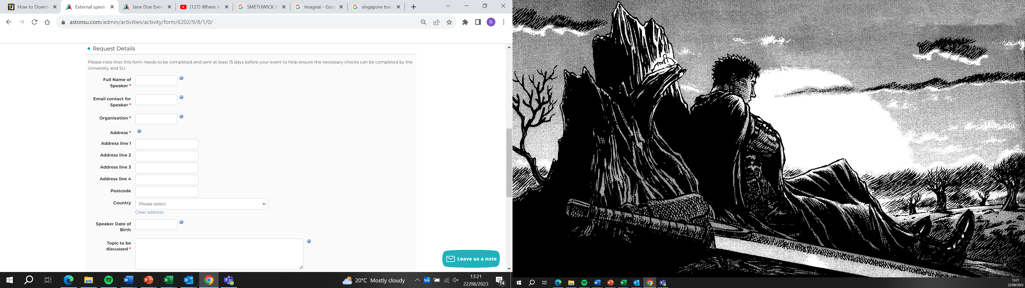

Transport Request Form:
For events involving the use of a vehicle, excluding public transport, such as trips or SU vehicle usage, the Transport Request form requires the following information:
1. Lead Point of Contact:
- Full name and contact number of the designated lead point of contact.
- This individual will be contacted in case of emergencies.
2. Travel Details:
- Provide the address of the destination to which you are traveling.
3. Departure and Return Information:
- Start date and time of departure.
- Date and time of return.
These details are crucial for coordinating and ensuring the smooth execution of transportation arrangements. Please fill out the form accurately and thoroughly to facilitate the necessary arrangements for your event.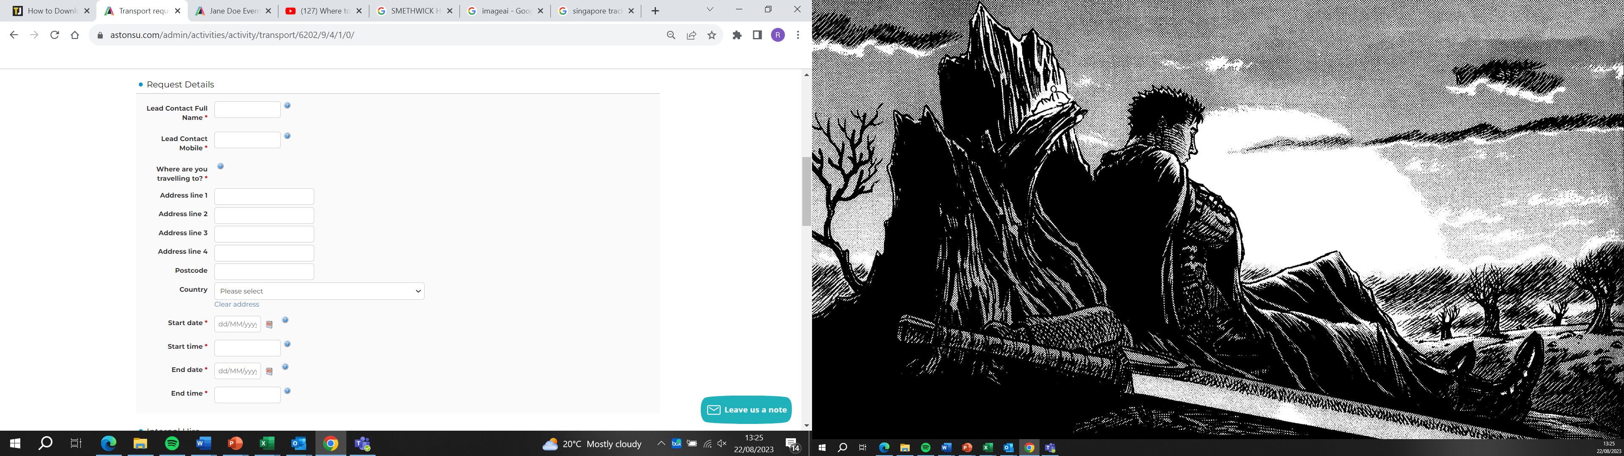
When selecting vehicles for hire from the SU, please choose the specific vehicles you require from the available options in the drop-down menu. This ensures clarity and accuracy in the vehicle booking process, helping to fulfil your transportation needs effectively.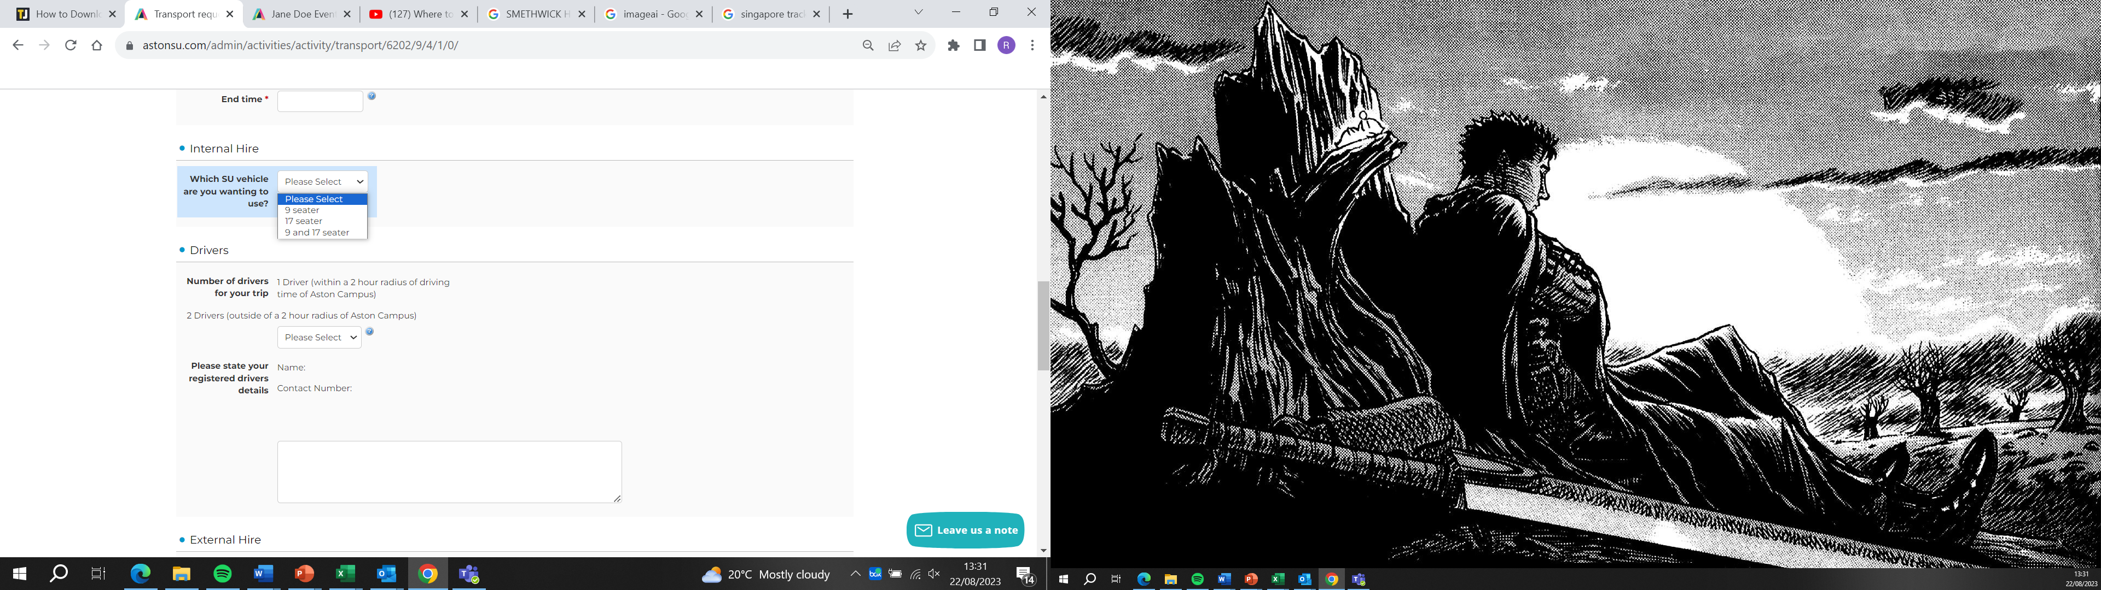
Specify the number of drivers you have by using the drop-down menu. It's important to note the following requirements for drivers:
1. For destinations within 2 hours of campus, a minimum of 1 driver is required.
2. For trips exceeding 2 hours away from campus, a minimum of 2 drivers is required.
Ensuring that you meet these driver requirements is essential for safe and compliant transportation for your event.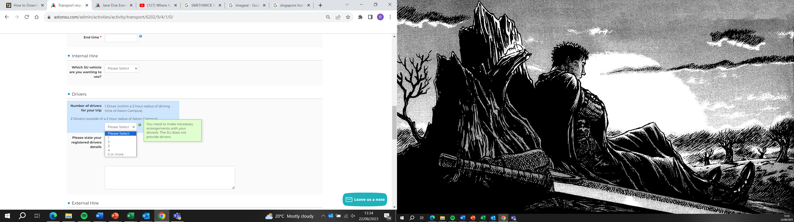
For each driver, provide the following details in the specified format:
Driver 1:
- Name: [Full Name]
- Contact Number: [Phone Number]
Driver 2 (if applicable):
- Name: [Full Name]
- Contact Number: [Phone Number]
Repeat this format for each additional driver as needed. Ensuring accurate and complete information for each driver is crucial for the transportation coordination of your event.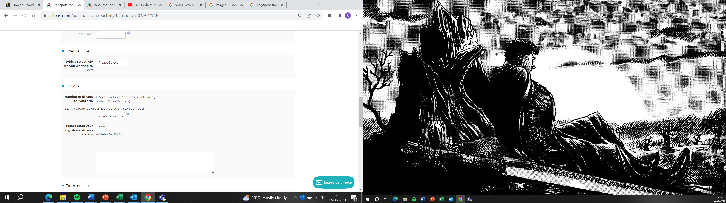

If you intend to hire an external vehicle, please complete the following section of the form:
1. Number of Passengers:
- Specify the total number of passengers for the trip.
2. Pick-up Time:
- Provide the pick-up time for both the outward and return journeys.
3. Van Requirements:
- Indicate whether you need a van for the trip.
- If a van is required, specify the size needed.
4. Coach Hire:
- Mention if you are considering hiring a coach for the event.
It's important to note that for all external bookings, a quote will be obtained and shared with you before confirming the booking. Providing accurate details in this section helps in obtaining the most suitable transportation for your event while considering passenger capacity and specific requirements.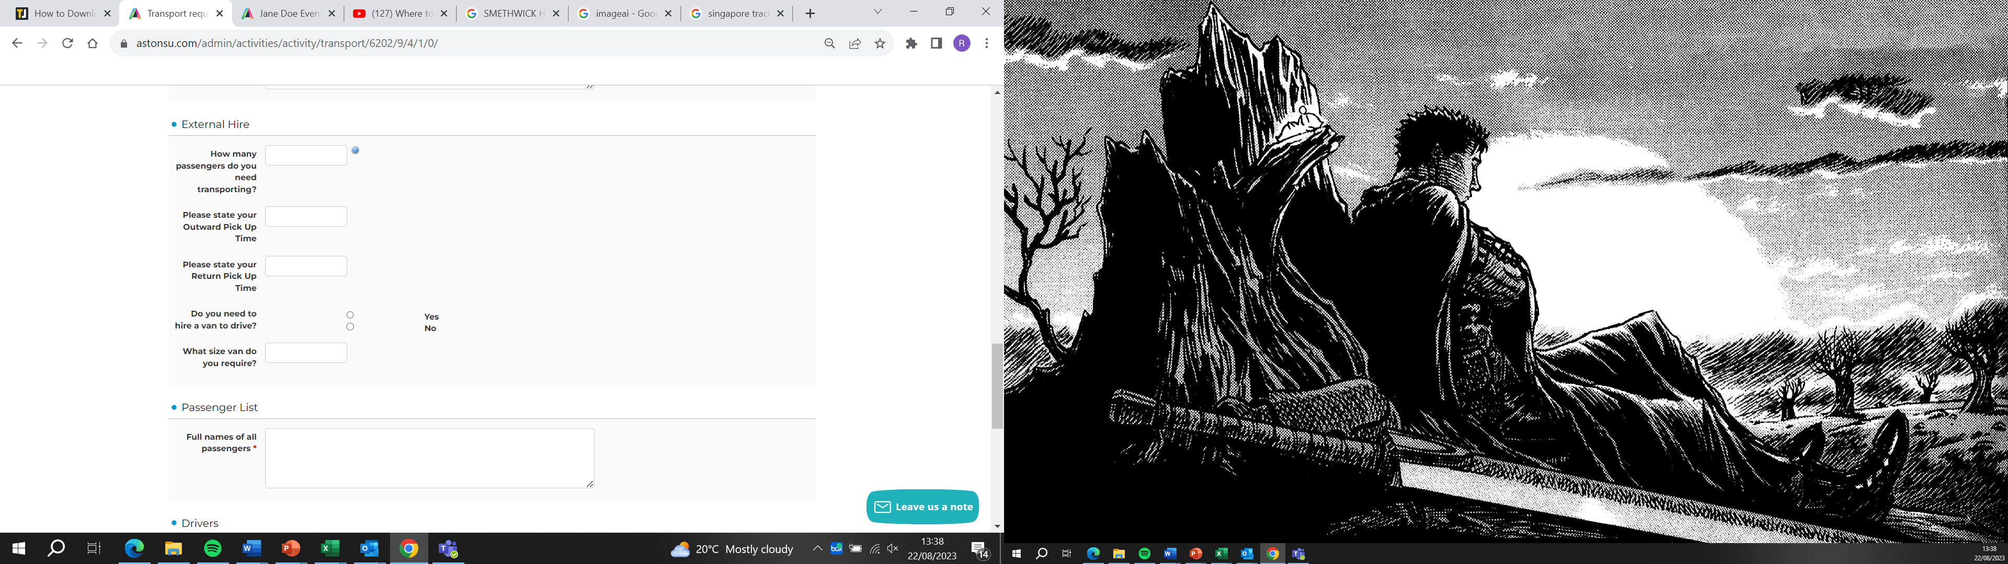

For the passenger list, provide the full names of all individuals who will be using the vehicle. Format the information as follows:
Passenger 1:
- Name: [Full Name]
Passenger 2:
- Name: [Full Name]
Continue this format for each passenger, ensuring that you include the complete names of all individuals who will be using the vehicle. This information is crucial for proper documentation and coordination of transportation for your event.
It's important to note that drivers intending to operate SU minibuses and vans must be registered with the SU and meet specific criteria. To be recognized as a suitable driver, individuals should meet the following requirements:
- Hold a valid UK Manual Driving Licence.
- Have a minimum of 2 years of driving experience.
- Be 21 years old or above.
- Have no points on their UK driving license.
If you meet these criteria, please contact the Student Activities & Voice Team for societies at societies.union@aston.ac.uk or for clubs at athletic.union@aston.ac.uk to initiate the registration process. This ensures compliance with the necessary standards for driving SU vehicles.

Trip and Tours Form:
To complete the form for travel off-campus lasting a minimum of 1 night for an event, provide the following details:
1. Departure and Return Time:
- Specify the exact departure time and date.
- Indicate the expected return time and date.
2. Accommodation Details (if applicable):
- If overnight accommodation is required, provide details such as the name of the accommodation, address, and any relevant reservation details.
These details are essential for coordinating and facilitating travel arrangements, ensuring that all aspects of the trip are appropriately planned and accounted for.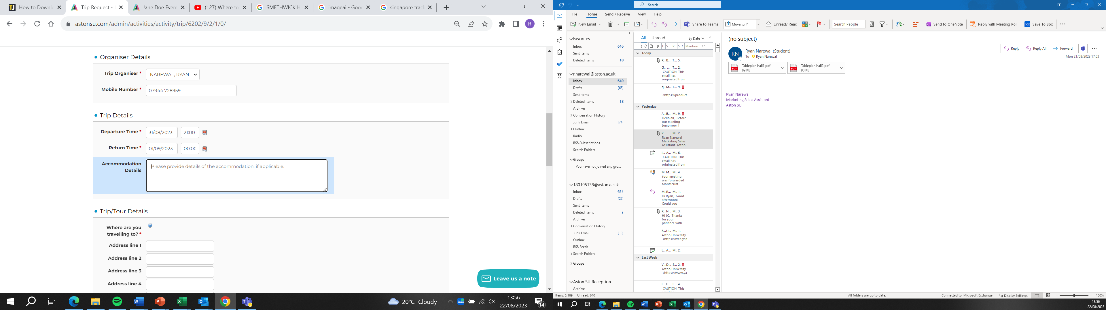

For the details of the trip, provide the following information:
1. Address of Destination:
- Specify the complete address of the location you will be traveling to.
2. Activities During the Trip:
- Outline the activities that will take place during the trip, providing a brief description.
3. Cost of the Trip:
- Clearly state the total cost associated with the trip.
4. Payment Plan:
- Indicate whether you prefer the costs to be paid in instalments.
5. Instalment Deadline Dates:
- If instalments are preferred, specify the deadline dates for each payment.
Providing these details ensures accurate planning, budgeting, and ticket arrangements for the event, allowing for a smoother and more organized execution of the trip.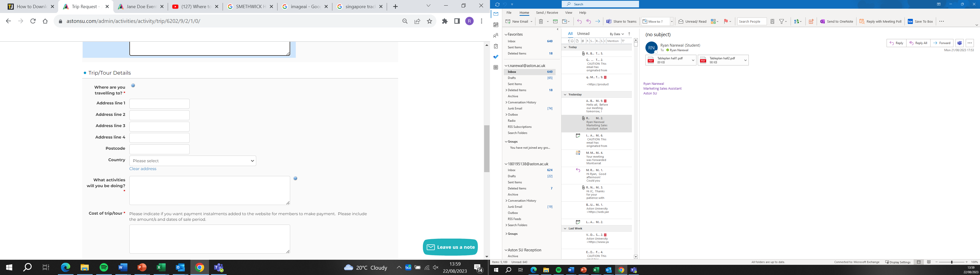
If you are using an external operator for your trip, please provide the name of the operator. Clearly specify this information to ensure that all logistical arrangements and communication channels are appropriately coordinated with the external service provider.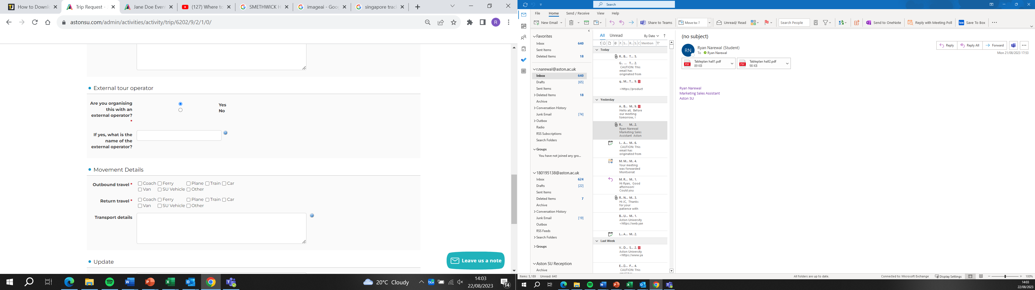

Outline how you will be traveling to and from the location for your trip. Specify the mode of transportation, whether it's by flight, ferry, or any other means. If available, provide relevant details such as flight or ferry numbers.
Additionally, for any necessary attachments, please share them via email with your corresponding administrator. This ensures that all essential documentation and information are properly communicated and stored for reference throughout the planning and execution of the trip.