Full Name:

Date of Birth: | Click or tap to enter a date.
Contact Number:

Address:

Email Address:

Student Number:
Club/Society:
Graduation Year:

Are you over the age of 21? | Choose an item.
Do you hold a full UK Driving License? | Choose an item.
Have you held your license for more than 2 years? | Choose an item.
Do you have any penalty points on your license? | Choose an item.
Do you have any penalty points pending on your license? | Choose an item.
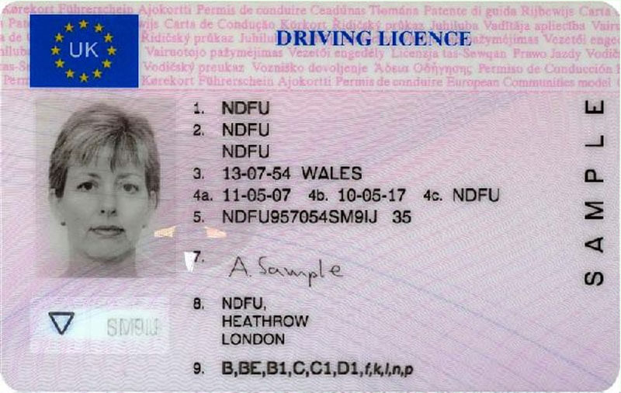

We require your full driving license number as highlighted in the sample to the left.

Generating a DVLA Check code:
- Follow this link: https://www.gov.uk/view-driving-licence
- Enter your driving license number, National Insurance Number & Postcode.
- Go to the “Share your licence information” tab and click the tab which says “Get a code”
Driving License Number:
DVLA Check code:
- Enter this code in the field below – please note the code is CASE SENSITIVE

Do you accept that Union Minibuses are only registered and insured to carry 17 people including the driver and should be used for Union business only?
Yes No

Have you received and read a copy of the Union Vehicles Drivers Guide and Terms & Conditions?
Yes No

Do you have any medical conditions that may affect your driving?
Yes No

Do you agree to inform the Union of any changes to your endorsements or your medical conditions?
Yes No

Do you agree to have your data shared with other clubs/societies who need drivers?
Yes No
I declare that, to the best of my knowledge and belief, the answers given on this form are true and accurate. I also understand that breaking any conditions of usage or purposely misleading the Union, I may be subject to disciplinary proceedings which could result in the suspension/removal of my eligibility to drive, fines for myself and my club/society, or any other punishment deemed reasonable by the Union.

Signed: ______________________ Date: _________________

This person has been accepted as a union driver:

Approved by: _________________ Signed: ________________ Date: ________

