Societies Ball Sponsorship
........................................................................................
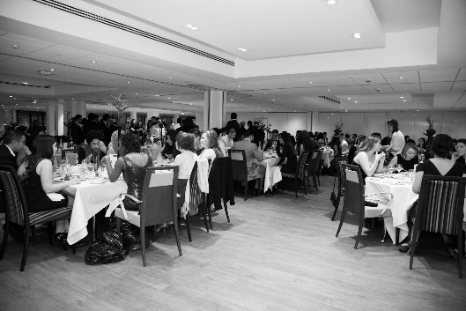
What is the Societies Ball?
It is a night to celebrate the success of our societies and the achievements of Aston University students. It is our opportunity to thank them for the sense of community they create at Aston, as they come together for a night to celebrate, reflect and relax.

Why should you sponsor the Societies Ball?
As a sponsor of Aston University’s Societies Ball, you will enjoy excellent exposure to all students who attend, through the tiered sponsorship offerings detailed below. Whether it’s delivering the keynote speech on the night, or promoting your brand through our extensive marketing and promotions for the event, you will have premium access to motivated Aston undergraduates, most of whom will be beginning the search for their graduate roles, placement opportunities or accommodation for next year.

Sponsorship Packages
Gold: £2,000
- Official ‘In Association with…’ partner on all promotional materials and tickets
- 10-minute keynote speech at the event
- Up to four seats at the event
- Advertise your company at the event with roller banners and/or on the plasma screens
- A marketing stand in the Students’ Union on two dates during the fortnight prior to the event
- A premium spot in the Student Activities newsletter
- Advertising on the SU plasma screens throughout the fortnight prior to the event
- A web banner advert on the SU website throughout the fortnight prior to the event
- Social media promotion twice a week during the fortnight prior to the event

Silver: £1,000
- An ‘Official Sponsor’ on all promotional materials and tickets
- Up to four seats at the event
- Advertise your company at the event on the plasma screens
- A marketing stand in the Students’ Union on two dates during the fortnight prior to the event
- A web banner advert on the SU website throughout the week prior to the event
- Social media promotion twice during the week prior to the event

Bronze: £500
- Listed under ‘Supporting Sponsors’ on all promotional materials and tickets
- Advertise your company at the event on the plasma screens
- A marketing stand in the Students’ Union on one date during the week prior to the event
- Social media promotion twice during the week prior to the event

Get Involved
If you want to get involved with Societies Ball, then please contact us at:
student.activities@aston.ac.uk
0121 204 5026

