Aston Students’ Union Awards Evening Sponsorship
........................................................................................
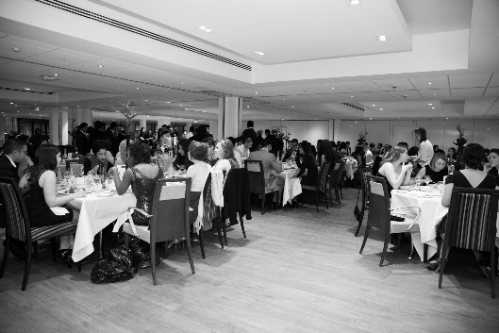
What are the Students’ Union (SU) Awards?
The Students’ Union Awards evening is a night to celebrate the great contributions made by the students to Aston University and Aston Students’ Union.
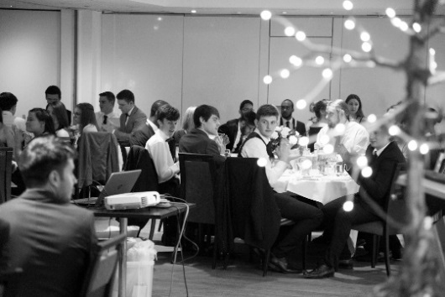
Why should you sponsor the SU Awards?
As a sponsor of the Aston Students’ Union Awards, you will enjoy excellent exposure to a number of Aston University’s most engaged and proactive students. Whether it’s delivering the keynote speech on the night, or simply getting your brand out there through our extensive marketing and promotional activity for the event, you will have premium access to motivated Aston undergraduates, many of whom will be searching for their graduate roles or placement opportunities.

Sponsorship Packages
Gold: £2,000
- Official ‘In Association With…’ partner on all promotional materials and tickets
- 10 minute keynote speech at the event
- Up to four seats at the event
- Advertise your company at the event with roller banners and/or on the plasma screens
- A marketing stand in the Students’ Union on two dates during the fortnight prior to the event
- A premium spot in the Student Activities newsletter
- Advertising on the SU plasma screens throughout the fortnight prior to the event
- A web banner advert on the SU website throughout the fortnight prior to the event
- Social media promotion twice a week during the fortnight prior to the event

Silver: £1,000
- An ‘Official Sponsor’ on all promotional materials and tickets
- Up to four seats at the event
- Advertise your company at the event on the plasma screens
- A marketing stand in the Students’ Union on two dates during the fortnight prior to the event
- A web banner advert on the SU website throughout the week prior to the event
- Social media promotion twice during the week prior to the event

Bronze: £500
- Listed under ‘Supporting Sponsors’ on all promotional materials and tickets
- Advertise your company at the event on the plasma screens
- A marketing stand in the Students’ Union on one date during the week prior to the event
- Social media promotion twice during the week prior to the event

Get Involved
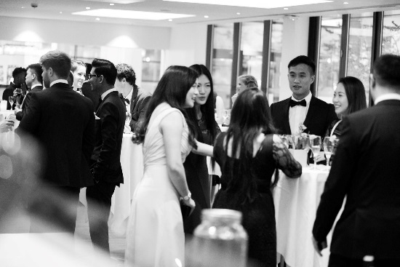
If you want to get involved with the Students’ Union Awards evening then contact us at the following:
student.activities@aston.ac.uk
0121 204 5026

