Aston Varsity Sponsorship
........................................................................................
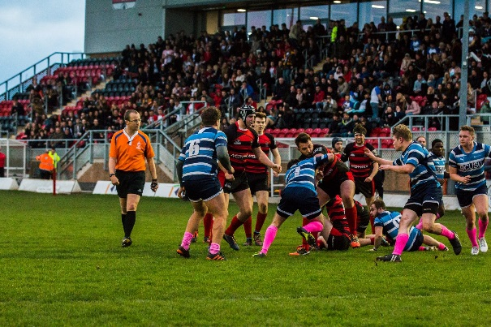
What is Varsity?
Aston’s Varsity is one of the most enjoyable and atmospheric sporting events in the academic calendar. Not only does it bring together local universities in healthy competition, but it’s a time for the supporters (made up of the student body and staff) to get involved, attend the matches, and engage in the social activities that accompany such a great event.
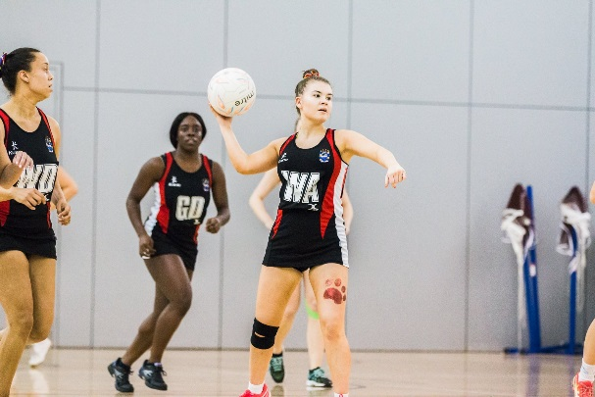
Why should you sponsor Varsity?
As a sponsor of Aston’s Varsity, you will enjoy excellent exposure to all students who participate and attend the fixtures through the tiered sponsorship offerings detailed below. By adding your brand to our extensive marketing and promotions for the event, you will have premium access to over 500 Undergraduates, most of whom will be beginning their search for their graduate roles or placement opportunities. With promotions being distributed through all our main channels, you will also gain access to our wider student body.
Sponsorship Packages
Gold: £2,000
- Official ‘In Association With…’ partner on all promotional materials, T-shirts and tickets
- Invited to attend all the fixtures, with premium seating/standing where available
- Advertise your company at the events with banners or other materials
- A marketing stand in the Students’ Union on two dates during the fortnight prior to the event
- A premium spot in the Student Activities newsletter
- Advertising on the SU plasma screens throughout the fortnight prior to the event
- A web banner advert on the SU website throughout the fortnight prior to the event
- Social media promotion twice a week during the fortnight prior to the event

Silver: £1,000
- An ‘Official Sponsor’ on all promotional materials and tickets
- Invited to attend all the fixtures
- Advertise your company at the events with banners or other materials
- A marketing stand in the Students’ Union on two dates during the fortnight prior to the event
- A web banner advert on the SU website throughout the week prior to the event
- Social media promotion twice during the week prior to the event

Bronze: £500
- Listed under ‘Supporting Sponsors’ on all promotional materials and tickets
- Advertise your company at the events with banners or other materials
- A marketing stand in the Students’ Union on one date during the week prior to the event
- Social media promotion twice during the week prior to the event

Get Involved
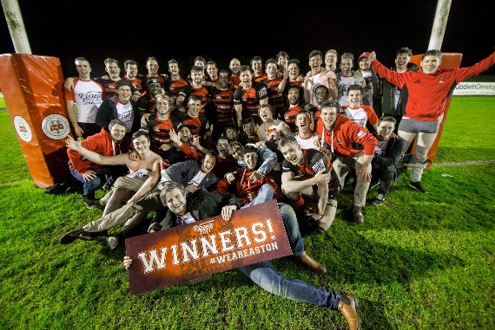
If you want to get involved with Aston’s Varsity, please contact us at the following:
student.activities@aston.ac.uk
0121 204 5026

