Filling in your Candidate Promo Pack image.

Download font

Download the font D-DIN.OTF sent to you.

Failing this, a default font you should use instead is Impact. Which should already be installed.

- To Download font click on the zip file and then click on D-DIN condensed bold.
- Once the file opens. Click install font and it will be uploaded onto font book (MAC)
- On WINDOWS, click on the font, and click the install button
- If this message appears click yes.

Candidate Promo Pack

Once you have filled in the presentation document, it needs to be saved as a jpeg to then upload onto social media.

- Go To file and click Export
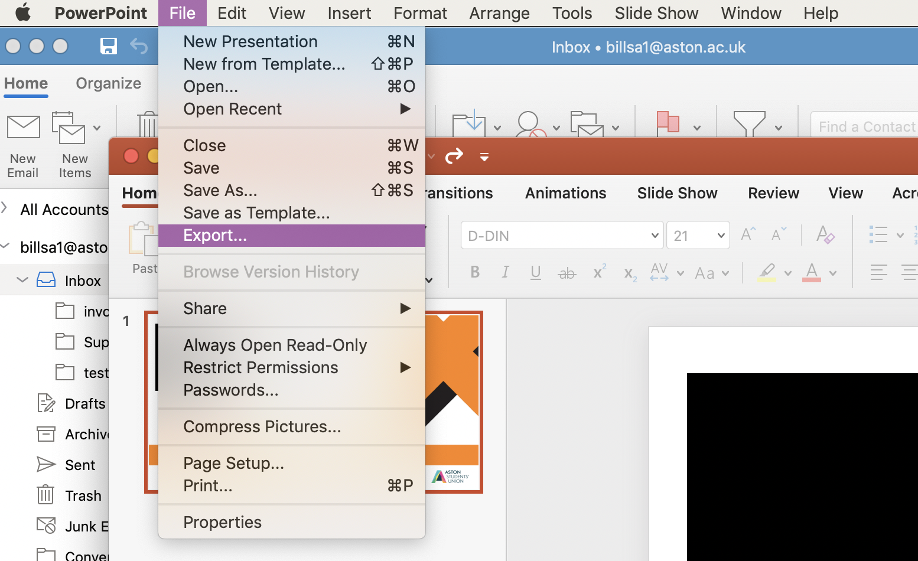

- Save the file under a suitable name and in your correct folder, and ensure the file format is set as JPEG.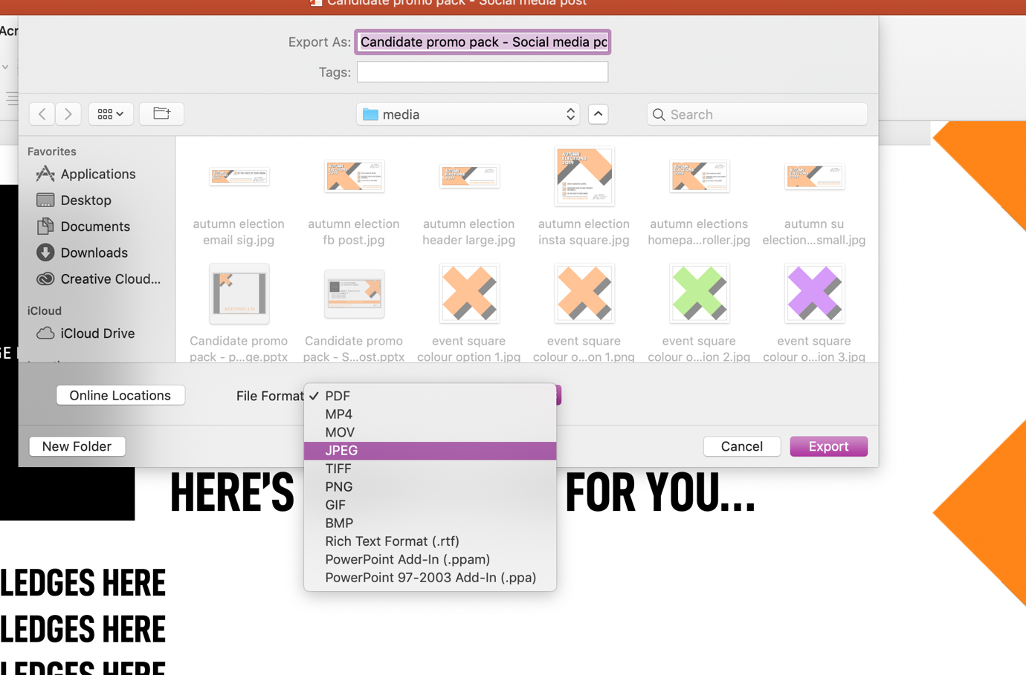

- Once you’ve clicked JPEG change the Width to the number 1200 and the height will automatically change to 631. Leave the height as this and click export.
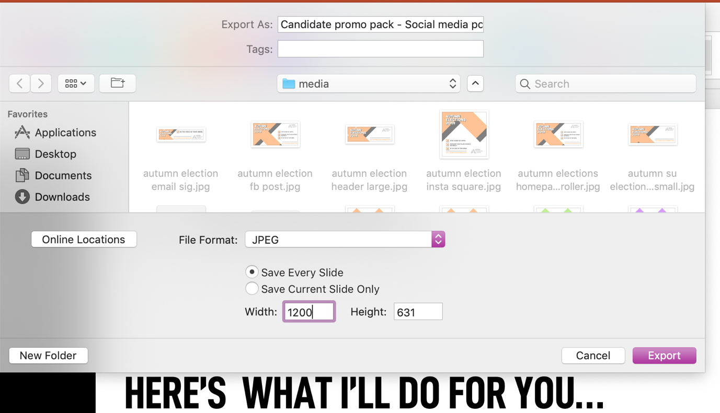

- You can now use this file as an upload on Facebook.
If you are struggling, send your presentation document to a.bills1@aston.ac.uk.

