Emergency Student Union Council Minutes_03.02.2022
Time: 16:00 – 18:00
Duration: 1hr 29m
Location: MB261
Chair: Union Chairperson
Minutes taken by: Student Engagement Coordinator (Student Voice)
Meeting is quorate (55 online and 15 in-person)
Meeting is quorate/not quorate
Approval of the agenda – approval not carried out as it is an Emergency Student Union Council
Change in Agenda order, UCU Strikes discussion changed to before NUS Strike discussion.
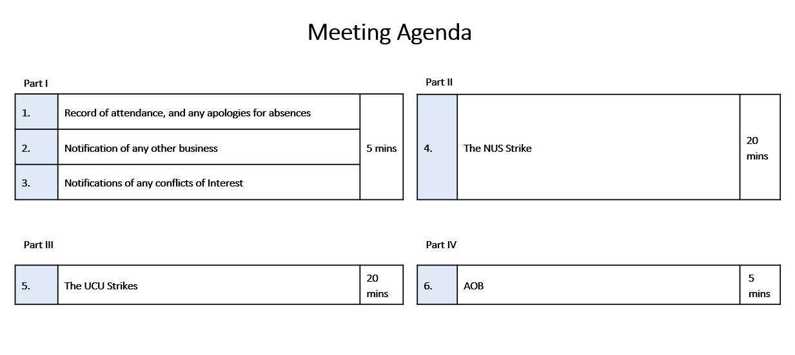
- Record of attendance, and any apologies for absences
  - Apologies
    - None
  - Absences
    - N/A
- Notification of any other business
  - None
- Notification of any conflicts of interest
  - Full-Time and Part-Time Student Officers conflict of interest with motion Aston Students’ Union agree to use Union resources to send Students’ Union Officers to London to take part in the protest
- Approval of previous Council meeting minutes (in order to ensure they are published by next meeting)
  - N/A
- Approval of Chairperson’s Rulings
  - N/A
- Matters arising
  - N/A
- ASU Council ‘New’ Motions
Motion A: Aston Students’ Union supports the strike action for USS
      - Mike Kirkman speaking on behalf of UCU
First thing that I want to say both to you here as members of the Students’ Union and all people listening to on Teams and also to all the other students, I am so sorry, genuinely sorry for further disruptions. From a personal point, the last two years have been worse two years of my life. This is probably the view of many people, and students with three years of disruptions. If there’s anything that Richard Billingham (Executive Director Of HR And Od) and we align, could do to avoid that we would do.
I am going to explain a couple of things regarding the strikes. There are what we call the four fights, pay, workload, equality, and casualisation (click here for more information). These are a national issue and both sides, unions and management are suffering. There has been no pay rise since 2010. People in the academic sector’s salaries are not meeting the inflation rates. I think today the Bank of England raised interest rates again and inflation is roaring through the roof so there's been no pay rise for 10 years which is kept up with inflation, so members of academic staff are about 20% lower in than they were ten years ago. This is a sector wide problem for many academic and support services staff because UCU represents managers like myself who are not academics and administrative staff in the academic field in particular many of the lecturers are working more than 50 hours a week. I understand this is a very bad time for students to have a disruption and have had disruption to Covid and getting online teaching was huge for all of us and many of you appreciate that, but now we’ve got a dispute where employers have made money in this time. We're also seeing universities and institutions make millions of pounds of operational surplus. This university is doing OK it's not making millions of pounds of surplus but we survived the pandemic better than ever but there are other institution making millions of pounds of surplus. Vice chancellors pay is huge, have a look on the Times Higher Education what some of these people are being paid, they are eye watering. Some employers do not wish to negotiate and I say this is a national dispute because we have not had a local dispute with Aston university management in the 11 years that I've been involved with. I don't know how many members will be taking action we voted two to one in a democratic ballot to take strike action that surprised me 51% to make the ballot legal and I thought that Aston being quite a conservative branch and I know that our members here are sick to the back teeth of not being able to do what they like to do. I've got a duty to do so I was very surprised that the branch actually voted to take action but they have voted to take action it's been a democratic vote and I have to go along with that. I don't know many members active what the disruption possible pensions dispute because that is it's complex we all know people in the country are living longer. I hope longer because I'm very close to be able to draw my pension and even the changes that they will be in the remaining time aside gotten employment will have negative impact but the proposals as they stand are that people will lose on average 35% of their take home pension more important the staff at the younger end of the careers are going to lose more and feels with the employers issues we all know that we've got to be some traction because people are living longer there's a dispute over the valuations you see you do not believe that the 2020 valuation was realistic because it was taken at the time employers have rejected the advice of the experts that they brought in 8 dialogue. I think from the employers side there is a feeling that's that used to you negotiate and who is in the middle affect students the people who are paying everybody research and that's what I feel hurts so much and I could tell you that any of my members anymore because I'm not the branch chair again have to keep remembering that but any of our members any of our members who take action will wake up on the 1st morning with a feeling of sickness it's like a pit picket lines picket lines in other areas with left nobody wants this and if there's anything that the student body here can doing to junction the National Union students to try to bring the two sides back together please do it I know you're talking about national student union strike later thank you very much for listening in again my heart goes out to you all
      - Richard Billingham
37% directed at the National Union because that's where my frustration is absolutely unnecessary if you see you don't want to impact students then don't strike to be self-indulgence on the top of UCU nationally it just doesn't need it just doesn't need to happen given the last two years especially the last two years all of us but I must admit sitting on the outside working at the university that's being difficult enough my heart goes out to students who have had the student experience of being on campus disrupted beyond imagination back in stop 2020 but that reason where the university community frustrated by the national dispute that makes it we're really supportive and work very closely with our local unions we completely respect the local union members have the right to withdraw their labour we will be doing to mitigate the impact for those areas that are actually affected so I think the outside is actually those areas that will be effective affected will be in specific subject areas and it won't be for the vast majority so we will be in the psychology it will be in social sciences other areas as well a lot of people want to experience the impact of this but for those who do that can seem massively unfair and I can't disagree with that particularly I just want to go without getting into game saying about this of course a different narrative completely different narrative here so take pensions in the first instance final types of organisation that offers what's called a defined benefit pension scheme benefit pension scheme is pretty much what it says view contribute as an employee the university contributes to your pension pot when you retire is a defined pension to get defined income those increasingly across sectors so those go back 40 years those were the type of pensions that were in place across the economy in all sorts of organisations over the last 20 years most organisations have got rid of them they almost don't exist in private set to increasingly there don't exist in the public sector because they are too expensive they are too expensive to maintain partly on the basis of the increasing longevity so from a pension scheme pov trustees who are not the universities is an independent body the trustees have to be sure that they have sufficient ongoing funds not just to pay to pensioners are we claiming on that pension now but for all of us who will be wanting to draw out pension in the future and that's where the problem is just what I want you to do because you probably don't know parents how much their employers contribute to their pension nationally the average contribution by employers is four and half percent to people's pension so that's four and half percent of your take home pay on average across the sip across all of the economy is what employers contribute here at the university 2 day the university contributes 21.4% save that pension 21% of everyone who's in that pension 21% is contributed to the pension to keep it going to be able to give the defined benefit employees as well have to contribute to that they have to contribute a third so at the moment they contribute 9.8% absolutely for younger members of staff it's really problematic because actually 9.8% of your take home pay if you're really early career academic is a significant chunk perhaps right at the point when actually you're starting a family or buying a home or actually you've got increase commitments and So what we are seeing is a lot of younger members of staff action drop out of the pension scheme if you drop out across all universities articulate mention screen levels of about 12 to 15% drop out which means they're not making any provision for their future because they're not able to afford to do that universities want to look at having a flexible scheme so I think the other point that what we're talking about here is usually represents our highest paid employees unite represents broader lower paid employees united not taking any action they don't have access to this pension scheme they have access to a different pension scheme where the university symbol in contributes quite high levels but that's a different type of pension scheme its defined contribution scheme so without going into the nuances about essentially what they're doing is building a pension part they know what's defined is how much is in that pot what they don't know is actually how long they going to live for however they need to spend but they do know they will know what they are what the pot of money they have to spend will be at the point of every time so it might be useful hi of an academic case 53,355 pounds the national average case is 29,000 pounds so UC represents highest paid individuals Broadway about lower paid individuals pay rise last year three of one half cents two people here before we have no pay rise because of the uncertainties around code but broadly actually this is not a low paid occupation in universities university staff are not just academic staff are paid what you might expect private sector employment the differentials Prince is between the highest paid the lowest paid members of staff 100 companies were really big company the difference between most highest papers four times what the what the lowest paid person is 250 can Vegas 37 times if you work in a university it's 6.9 times the size finish school anyone with the school your average pays 22,000 pounds here Aston the average pay of Aston employee is 3830 against my appointment its own is an unnecessary dispute both in terms of pensions and in terms of plan that's what we will really don't want it to happen we will work closely with we respect that their decision have a really good working relationship I'd like to think between us we've created a good employment environment but instinct we are back to face potentially tenders industrial action why would end I saying is the university will do everything in its power to try to mitigate any disruption for people to ensure comes that you students expect are attainable things that we need to make changes to ensure that in place then we will do that work closely with the student union you know if if you've got queries or worries or fears absolutely urge you to talk to Yasmeen talk to Paige because they communicate with us and we can try to ameliorate the worst impacts thank you
Question and Answers:
Q: Could it be made clear if these average wages are mean averages or median averages?
A: Median
Q: Do you not think its slightly problematic by comparing the salaries of academics with other sectors? Everyone deserves to be paid fairly for their labour. Aston represents the highest paid UCU members?
A: Essentially have 10 grade Unite 1-6 UCU can 7 or higher.
Few academic staff that are represented by unite – most fall into the higher paid category – 30,000 – the comparisons should provide some context –
Mike
UCU academic staff – to say they are at the top is not accurate
Q: You’ve shared some extensive data – but did not share about the work load – it is important to recognize – i.e. 60 hours a week and would mean that they’re hourly pay is lower. Can you expand on this?
A: We work closely with the union on academic workload. Some do just teach, T&R, teaching and research – have to have time to do this – depending on the wider roles. We have work to do in some areas, but it is not a universal experience – early career academics – unfair allocation of duties – are perhaps on more junior academics – it’s a live issue and we’re working through it. It is more troublesome in other places; the casualization isn’t an issue at Aston – we are of a solid employment.
Gender gap - 2/3 are women in lower paid jobs
Q: Final years have been through three years of strikes and covid, and keep happening year on year – what does UCU want. What is the point of it?
A: We can’t walk away from the situation. We are responsible. For young lectures and people with commitments. Trade union have established a lot of what we take for granted today. Fear for the sector and for the students, UCU will not walk away. Talented academics in professional services will choose to walk away and the sector will suffer. We can’t except what the conditions that employers throw at us.
Come to the table with meaningful negotiations
Richard:
Pension – UCU have failed to put together a proposal for pension
Comment from a student: Staff learning conditions are our learning conditions
Motion B: Aston Students’ Union supports the strike action for the Four Fights
Union Council Resolves
- Aston Students’ Union supports the strike action for the Four Fights
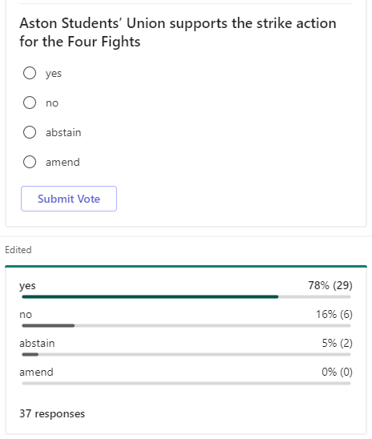
Motion passed: 78%
Motion C: Aston Students’ Union agrees to allow its facilities to be used by Aston University UCU members
Union Council Resolves
- Aston Students’ Union agrees to allow its facilities to be used by Aston University UCU members
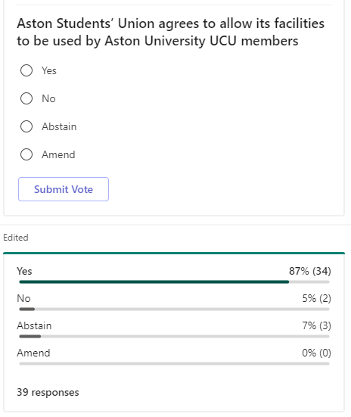
Motion passed: 87%
Motion D: Aston Students’ Union supports the NUS Student Strike for Education: Walk Out Teach In
Union Council Notes
- That students have increasingly had their education marketized and must take action to ensure the quality of their education and student experience.
Union Council Believes
- Students have the right to take strike action, and their Students’ Union should support them in this.
Union Council Resolves
- That Aston Students’ Union supports the NUS Student Strike for Education: Walk Out Teach In

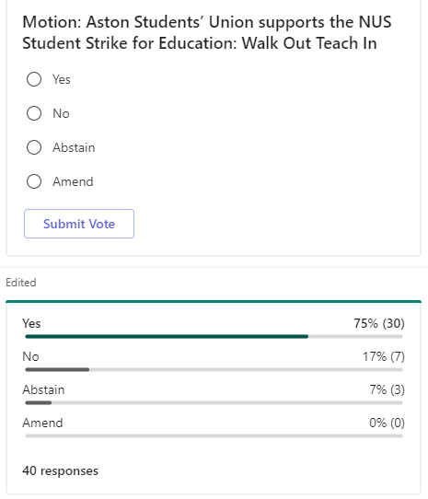
Motion passed: 75%
Motion E: Aston Students’ Union agree to use Union resources to send Students’ Union Officers to London to take part in the protest
Union Council Notes
- That students have increasingly had their education marketized and must take action to ensure the quality of their education and student experience. As a result the NUS are holding a protest in London and are calling on Students’ Unions across the country to come to London and join in the protest.
Union Council Believes
- That is the responsibility of elected Officers to represent the opinion of the student body.
- That elected Officers should be able to represent their student body without incurring any financial obligations.
Union Council Resolves
- That Aston Students’ Union agree to use Union resources to send Students’ Union Officers to London to take part in the protest
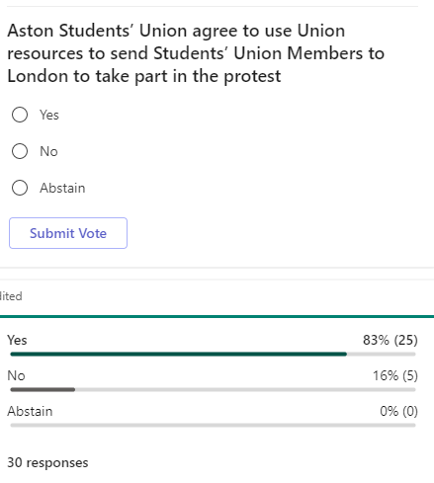
Motion passed: 83%
Motion F: Aston Students’ Union members would like the Aston Students’ Union Staff and Officers to hold an on-campus strike on the 2nd of March 2022
Union Council Notes
- That students have increasingly had their education marketized and must take action to ensure the quality of their education and student experience. As a result the NUS are holding a protest in London and are calling on Students’ Unions across the country to come to London and join in the protest, however, this is not feasible for every student.
Union Council Believes
- That it would be appropriate to hold an on-campus strike.
Union Council Resolves
- Aston Students’ Union members would like the Aston Students’ Union Staff and Officers to hold an on-campus strike on the 2nd of March 2022
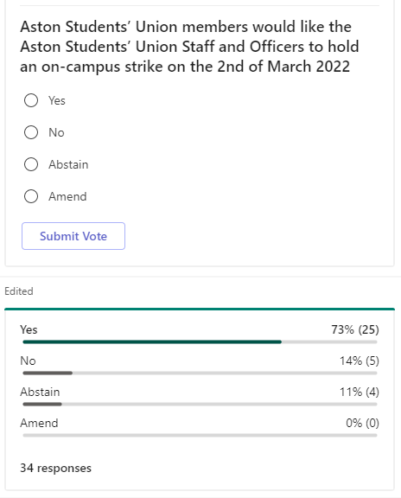
Motion passed: 73%
Comment from student:
There comes a point where year in and year our on the state of their education. NUS 10 years ago, education, appropriate to hold a strike. Historically it is a low academic day, and that is why they have picked a Wednesday. Opportunity to discuss your course content with your peers. Outreach – therefore we have held it a month in advance – so this can give us enough time to mobilize and promote the strike effectively.
50 us is not a lot but it is something and one person’s voice might be enough.
At present there are only mentioning this strike. This is first in four years I have been here. And they want to combine efforts in one day. They are not saying the students have to strike, this is individual preference. What we’re asking is what the Union’s stance is.
I think that I think it be helpful to perhaps look at it as we can like we are in favour of exploring what options are there is and we don't all have to buy we don't have to pay 100 quid tickets train tickets for everyone we can get coach deals that the that the union has Connexions with National Express so yeah I think it's worth think about that isn't it sound also decide on whether we make provision for students can I am I allowed to vote students can because at the moment only it's only saying we the union say that we can use union resources to send officers to go and join the protest in London I'm suggesting we amend it to say that the I'm sitting there somebody puts forward an amendment 2 yeah so if you would like are you okay seconded system update sorry.

- Amendment(s) of Motion(s)
N/A
- Democracy Update
N/A
- Trustee Board Report
N/A
- CEO Report
N/A
- Full-Time Officer Feedback and Question Time
N/A
- Part-Time Officer Feedback and Question Time
N/A
- Fast Track Approvals
N/A

