ASTON UNIVERSITY

ACADEMIC APPEALS PROCEDURES

Please note: If you wish for guidance on how these procedures work and/or how you might apply for an academic appeal, please contact either your Personal Tutor or the Advice and Representation Centre (ARC)

1. Purpose and Scope

This document contains procedures for dealing with appeals from students against the decisions of Boards of Examiners for undergraduate and postgraduate programmes. The procedures apply to appeals against the decisions of Boards of Examiners for both qualifying and final examinations.

These procedures are not intended to supersede the following existing provisions for students to make representations to Boards of Examiners prior to decisions being made as defined in the General Regulations for each level of study Undergraduate, Postgraduate, Postgraduate Research).

2. Appeal Procedure

General
2.1 A student wishing to appeal to the University against the decision of a Board of Examiners may appeal, if they are able to meet one or more of the grounds set out in 2.4 to the Secretary and/or Chair of the Academic Appeals Committee. The application form to make an Academic Appeal can be found in Appendix III of this document.

2.2 There is no right of appeal against the academic judgement of examiners. Disagreement with the academic judgement of a Board of Examiners in assessing the merits of an individual piece of work or in reaching a decision on a student’s progress or on the final level of an award, based on the marks, grades and other information relating to the student’s performance, cannot in itself constitute grounds for an appeal.

Time limits
2.3 The student must make any appeal against the decision of a Board of Examiners to the Secretary of the Academic Appeals Committee in writing using the University Appeals Application (see Appendix II). The Appeals Application with all supporting evidence must be received by the Secretary of the Appeals Committee not later than 14 days, including weekends and public and University holidays, after the student's transcript of marks have been issued on MAP (My Aston Portal).

Allowed grounds for appeal
2.4 The student must state the grounds on which the appeal is made and attach any supporting documentary evidence (e.g. medical certificates). The student’s grounds for appeal must fall into one or more of the following categories:

a) that there has been an administrative error or that some other material irregularity relevant to the assessments has occurred.

b) that the assessment procedure and/or examinations were not conducted in accordance with the approved regulations.

c) that the student’s performance was adversely affected by illness or other specific factors which they were unable for valid reasons to submit to the Board of Examiners before it reached its decision. (It will be very difficult to appeal under these grounds as all students are required to bring exceptional circumstances to the prior attention of the Board of Examiners, and accordingly, evidence would be required that there were very good reasons for failing to notify the Board of Examiners of any factors affecting their work e.g. a medical condition diagnosed after the meeting of the Board. It is the responsibility of the Schools to inform students of the specific arrangements and deadlines for the submission to the Board of Examiners of exceptional circumstances).

2.5 Any member of staff of the University may request a review of the decision of a Board of Examiners with appropriate grounds (i.e. one or more of those listed in 2.4 above). The request for review must be made in writing, including grounds and supporting documentary evidence to the Secretary of the Academic Appeals Committee, to be received not later than 14 days, including weekends and public and University holidays, after the student's transcript of marks have been issued by the appropriate School on MAP (My Aston Portal).

3. The Appeals Process

Students are encouraged to seek feedback and guidance from their appropriate School prior to deciding whether to complete the appeal form and submit an appeal. This may help students to understand how decisions were arrived at and also give the School the chance to address concerns on an informal basis.

Consideration of grounds for appeal
3.1 The Secretary of the Academic Appeals Committee shall consider the student’s appeal submission to ensure that there are appropriate grounds to initiate the appeals procedures. In considering the submission the Secretary shall endeavour to ensure that an appeal does not progress to the full hearing of the Academic Appeals Committee if they consider that the student has no real prospect of success. This judgement shall be based on their general impression of the claims made and the benefit of any doubt shall always be given to the student. Where appropriate, the Secretary of the Appeals Committee may seek information relevant to the appeal from the Chair and other officers of the relevant Board of Examiners (or the appropriate Associate Dean of Research for appeals from research students) to assist them in determining whether or not the student has grounds to initiate the appeals procedures. However, they shall not make any attempt to weigh the evidence or to assess competing claims (i.e. the Chair and the Secretary are not responsible for determining the merits of the appeal, having regard to the evidence produced by both sides). (This articulation of the role of the Chair and Secretary of the Academic Appeals Committee follows the advice of the University Visitor, the Lord Chancellor, Lord Falconer of Thoroton in a ruling in January 2007).

The student will be informed in writing if there are no appropriate grounds to initiate the appeals process.

Informal process
Stage 1
3.2 If an appeal can be resolved informally by the Secretary and/or Chair of the Academic Appeals Committee in conjunction with the Chair of the Board of Examiners and any other appropriate persons, then such action should be taken provided that it is in accordance with the current regulations. The Chair of the Board of Examiners may take Chair’s action, with the approval of the External Examiner(s), in changing the original decision of the Board or agree to put new evidence to the full Board, without the need to hold a meeting of the Academic Appeals Committee. In such cases, notice of such decision shall be dispatched by the Secretary of the Academic Appeals Committee to the University email address, unless due to a students status this is inactive. In which case the students personal email address will be used. Such communication shall be deemed to be sufficient and the duty to inform the student will be completed.

3.3 Should the appeal be upheld as part of the informal process, yet the outcome is not satisfactory to the student, the student may request an Appeal Outcome Review.
3.4 If the student has no grounds under which to request an Appeal Outcome Review the student may request a Completion of Procedures letter so that they may take their case to the Office of the Independent Adjudicator. To request a Completion of Procedures letter the student should write to: Secretary to the Academic Appeals Committee, Student and Academic Services, Aston University, B4 7ET or by email to sas_academicappeals@aston.ac.uk no later than 31 days after the date on the appeal outcome letter (Please put Completion of Procedures Letter Request in the email subject box).

Stage 2 Appeal Outcome Review

A student can request an Academic Outcome Review under the following grounds:

- a review of the procedures followed at the formal stage if it is believed the procedures were not carried out in line with Regulations
- a consideration of whether the outcome was reasonable in all the circumstances
- new material evidence which the student was unable, for valid evidenced reasons, was unable to provide earlier in the process.

4.2 The Appeal Outcome Reviewer will consider the case and consult with other staff as appropriate. The outcome of the review will be communicated to the student by the Secretary to the Academic Appeals Committee usually within fifteen working days of receipt of the request to review. The student will be automatically issued with a completion of procedures letter.

4.3 If the Appeal Outcome Review is upheld but no agreement can be made with the Chair of the Board of Examiners the student will be invited to attend a meeting of the Academic Appeal Committee which will be made up of members who were not involved in the original decision.

4.4 If the student remains dissatisfied at the conclusion of the Appeal Outcome Review they student may apply to the Office of the Independent Adjudicator for Higher Education as the internal process of the University would have been completed (see section 5.0 Independent Review)

Formal process - Senate Academic Appeals Committee
3.4 In appropriate cases meeting of the Senate Academic Appeals Committee will take place. The Committee will run as follows: (Appendix II)

3.4.1 Composition

Vice-Chancellor or nominee (Chair)
Two members of Academic staff taken from either the Senate membership, members of the Learning and Teaching Committee or are Programme Directors (not from the same School as the applicant)
A representative of Aston Students’ Union (nominated by the President)
Secretary to the Academic Appeals Committee

No person who was a member of or was concerned in any way with the proceedings of the Board of Examiners will be a member of the Academic Appeals Committee

3.4.2 Terms of Reference

The Academic Appeals Committee shall have the following functions:

i) to consider appeals against the decision of a Board of Examiners on the grounds that, for valid reasons, the Board was not aware of certain factors which adversely affected a student’s performance; or that a material administrative error or irregularity in the conduct of assessment has occurred; or that the assessment procedure and/or examinations were not conducted in accordance with the approved regulations.

ii) to report its decisions to the Senate.

3.5 A student whose appeal will be heard by the Academic Appeal Committee shall be sent notice of the meeting to the students University email address, or where this is inactive to their personal email address, not less that five working days before the scheduled meeting.

3.6 A student with grounds for appeal shall have the right to appear before and be heard by the Committee, accompanied and/or represented by an independent representative, such as an advisor from the Advice and Representation Centre, or a chosen member of staff of the University, to present witnesses, and to submit a written statement outlining the grounds for appeal.

3.7 The Committee shall be concerned with aspects of a procedural or personal nature, and not with testing the academic judgement of a Board of Examiners. In order to facilitate its investigations, the Committee shall have access to relevant material evidence (including: the programme regulations, the minutes and papers of the Board of Examiners) and shall require the Chair of the Board (or the appropriate Associate Dean of Research for appeals from research students) to submit evidence in support of the decision made concerning the student in question. In addition it may require the attendance of witnesses.

All paperwork for consideration by the Commitee will be sent to the student, their representative and all Committee members not less than 5 working days before the scheduled meeting

3.8 At conclusion of the proceedings all non-members of the Committee will be asked to withdraw and the Committee shall reach its decision in private. The Committee shall have the power to make one of the following decisions on behalf of the Senate:

i) that the student’s performance has been affected by exceptional circumstances, of which the Board of Examiners was not aware, and that the Board is requested to review its decision accordingly.
ii) that on the basis of substantiated evidence of administrative error or other material irregularity the Board of Examiners is requested to review its decision accordingly.
iii) that on the basis of conclusive evidence of a significant irregularity in the conduct of, or arrangements for, an assessment, the decision of the Board of Examiners concerning one or more candidates be annulled and the assessment retaken.
iv) that the appeal be rejected.

3.9 The Secretary of the Academic Appeals Committee shall be responsible for informing the Chair of the relevant Board of Examiners (or the appropriate Associate Dean of Research for appeals from research students) of the Committee’s decision.

3.10 The Chair of the Board of Examiners (or the appropriate Associate Dean of Research for appeals from research students) will ensure, where appropriate, that the Board reconsiders its decision in the light of the recommendations of the Academic Appeals Committee, having regard to its role in ensuring that the student is fairly assessed within the programme regulations as an individual and in relation to their peers. Where the Board wishes to have further evidence of the student’s performance, it may require an alternative form of assessment appropriate to the student’s circumstances and the requirements of the programme regulations, before reaching its final decision.

3.11 The Chair of the Board of Examiners (or the appropriate Associate Dean of Research for appeals from research students) shall inform the Secretary of the Academic Appeals Committee of the Board’s decision within five working days of the meeting of the Board.

3.12 The Secretary of the Academic Appeals Committee shall inform the student in writing of the Board of Examiners’ decision.

3.13 If a Board of Examiners which has been requested to review its decision in respect of 3.6 ii) or iii) above, does not modify its decision, the Senate shall have the right to annul that decision if in its opinion due and proper account has not been taken of the relevant factors specified by the Academic Appeals Committee.

3.14 The Academic Appeals Committee shall not have the power to vary the approved general or programme regulations or to override the prescribed authority of an External Examiner.

4. Appeal Outcome Review (Appendix I)

4.1 If the formal stage - Senate Academic Appeals Committee was initiated at the outset of the appeal process and was not a result of an Appeal Outcome Review the student may request an Appeal Outcome Review under the following grounds:

- a review of the procedures followed at the formal stage if it is believed the procedures were not carried out in line with Regulations
- a consideration of whether the outcome was reasonable in all the circumstances
- new material evidence which the student was unable, for valid evidenced reasons, was unable to provide earlier in the process.

4.2 The Appeal Outcome Reviewer will consider the case and consult with other staff as appropriate. The outcome of the review will be communicated to the student usually within fifteen working days of receipt of the request to review.

4.3 If the Appeal Outcome Review is upheld and agreement cannot be made with Chair of the Board of Examiners a meeting of the Academic Appeal Committee will be held which will be made up of members who were not involved in the original decision. The student will be invited to attend this meeting which will be held as the Appeal Outcome Review.

4.4 If the student remains dissatisfied at the conclusion of the Appeal Outcome Review they may request a Completion of Procedures Letter from the Secretary of the Academic Appeals Committee.

Independent Review

5.1 If a student is not satisfied with the Appeal Outcome Review they may apply to the Office of the Independent Adjudicator for Higher Education (OIA) for an independent review of their case. The OIA operates an independent student complaints scheme pursuant to the Higher Education Act 2004.

5.2 The OIA will normally review a case only if all internal University procedures have been exhausted. Complainants who are considering an application to the OIA are therefore advised to contact the Secretary of the Academic Appeals Committee to confirm that this is the case and to obtain a 'completion of procedures letter', if this has not already been provided.

5.3 Aston, in common with all English universities, is required to comply with the Rules of the OIA's Scheme. The OIA has the power to recommend remedies to universities which can include offering compensation to complainants.

5.4 The service provided by the OIA is free to students. All complainants and enquirers to the OIA will be treated fairly and with respect, and in a positive spirit of support for good relations between all members of the Higher Education sector.

5.5 OIA provides an introduction to the student complaints scheme on its official website at www.oiahe.org.uk/summary.asp As part of its mission to identify and disseminate information about its work and how it makes its adjudications, OIA publishes a sample of anonymised adjudications on its website. They can be found at www.oiahe.org.uk/case-reports.asp
APPENDIX I

Academic Outcome Review Process

- If a student is dissatisfied with the outcome of their appeal, whether this is at the end of the informal or formal process, they must within fourteen days of receiving the written outcome of their appeal, submit a written request for an Academic Outcome Review Process to: Secretary to the Academic Appeals Committee, Student and Academic Services, Aston University, B4 7ET or can be sent by email to sas_academicappeals@aston.ac.uk (Please put Appeal Outcome Review in the email subject box and your student number).

- On receipt the request will be acknowledged and referred to a member of the Academic Outcome Review panel.

- The review outcome will usually be communicated to the student by email to their Aston University email address within fifteen working days of receipt. Students need to be aware that during vacation time it might take longer to receive a reply due to the availability of staff.

- Composition of the Academic Outcome Review Panel

- Any academic member of staff can apply to be a member of the panel. Requests for Appeal Outcome Review will be allocated to a member of panel who is not from the School the student is enrolled with.
- The panel members work individually to reach their decisions
- The Academic Outcome Review Panel member may consult with the relevant staff in the appropriate School and/or the Secretary to the Academic Appeals Committee if appropriate

- If the Academic Outcome Review upholds the allowed grounds for review and agreement cannot be made with Chair of the Board of Examiners the case will be referred to a meeting of the Academic Appeals Committee. The Committee will be composed of members who have had no previous involvement in the case.

- Questions for the Academic Outcome Reviewer to consider are:

- Were the relevant procedures followed during the formal stage?
- Was the outcome reasonable in all the circumstances?
- Has the student received clear reasons why the academic appeal was rejected at the formal stage?
- If new material evidence has been provided has the student given valid reasons for not supplying this earlier?

- All decisions of the Academic Outcome Review Panel members will be communicated to the student by the Secretary of the Academic Appeals Committee and will be included in annual review of the Academic Appeals Process.

- Following the outcome of the Academic Outcome Review the student will be provided with a Completion of Procedures letter so that they may take their case to the Office of the Independent Adjudicator.

APPENDIX II

PROTOCOL FOR MEETINGS OF THE SENATE ACADEMIC APPEALS COMMITTEE

1. The Chair shall outline the procedure for the meeting to both parties.

2. The Chair will ask the appellant (or representative) to present their case in support of the appeal, and to introduce any witness(es) in support of the case.

3. The Chair may ask questions of the student and/or representative and/or their witness(es) at any time.

4. The Chair will ask the Chair of the Board of Examiners (or the appropriate Associate Dean of Research for appeals from research students) (or nominee) to respond to the appeal, and to introduce any witness(es) in support of the response.

5. The Chair may ask questions of the Chair of the Board of Examiners (or the appropriate Associate Dean of Research for appeals from research students) (or nominee) and their witness(es) at any time.

6 The Chair will ask the appellant (or representative) to summarise their case.

7. The Chair will ask the Chair of the Board of Examiners (or the appropriate Associate Dean of Research for appeals from research students)(or nominee) to summarise their case.

8 The parties will be asked to leave the meeting and the Committee will consider the evidence that has been heard in private, and may at this stage choose to reconvene the hearing to a later date in order to obtain further evidence or advice from other parties. Should this be the case, all parties will be invited to attend the reconvened meeting.

9. The Chair will announce the Committee’s decision, either by calling the parties together or in writing. The outcome of the hearing will normally be confirmed in writing within five working days.
APPENDIX III
ASTON UNIVERSITY
ACADEMIC APPEAL APPLICATION
Students are encouraged to seek feedback and guidance from their appropriate School prior to deciding whether to complete and submit an appeal. This may help you address any concerns on an informal basis ensuring that you have grounds for an appeal.
You should save this form to your computer, complete it with your details. The completed form can be posted to the Secretary to the Academic Appeals Committee, Student and Academic Services, Aston University, B4 7ET or can be sent by email to sas_academicappeals@aston.ac.uk (Please put Academic Appeal AND your student number in the email subject box).
YOUR PERSONAL DETAILS
Your Name (in full)
Student Registration Number |  |  | Year of programme (1, 2, etc.)
Your School
Programme of study
Your contact address
Telephone no.
E-mail address
Do you have an adviser or representative assisting you with this form?  If yes, would you like a copy of the response to be sent to this person as well as to you ? (if yes please let us have their name and address to which it should be sent). |  |  |  |  | Yes/No  Yes/No
Please confirm that you have read and understood the allowed grounds for appeal as outlined in the Academic Appeals Process |  |  |  |  | (please tick (√) box to confirm)
Signed |  |  |  | Date

YOUR APPEAL
Please set out your academic appeal clearly and briefly.
What is the decision against which you are appealing?
What is your preferred outcome?
(Please note that your appeal may be upheld but it may not be possible to grant your preferred outcome)
Indicate with a tick in the relevant box(es) the ground(s) under which you wish to appeal (see para 3.1 of the procedure):
Tick (√)
Relevant Box(es)
An administrative error or some other material irregularity relevant to the assessments has occurred, on behalf of the University
The assessment procedure and/or examinations were not conducted in accordance with the approved regulations.
My performance was adversely affected by illness or other specific factors which I was unable for valid reasons to submit to the Board of Examiners before it reached its decision.
There are therefore two parts to this ground of appeal. You must be able to satisfy both parts.
- You must provide evidence of the factors that affected you, AND
- You must explain what your reasons were for not being able to notify the School Board of Examiners in advance. You may provide relevant evidence.

(If you wish to appeal on these grounds, please ensure that you provide clear evidence, not only of the factors that affected you, but also explaining why you were not able to notify the Board of Examiners in advance, for example, a medical condition diagnosed after the meeting of the Board which can be demonstrated to have affected your performance.

Describe here why you believe you have grounds for appeal, questions that you should try to answer in your appeal (these can be deleted once you have read them to allow for you to type in your appeal).
You should make reference to your evidence and explain how this supports your appeal.
Which assessment was affected (module code and title, dates of assessment)?
What evidence are you providing in support of your academic appeal? What evidence are you submitting that was previously unavailable when your Extenuating Circumstance decision was made?
Why was the evidence previously unavailable when you made your Extenuating Circumstance claim?
What does the new evidence show?
How did this affect the mark or grade you were given?

Evidence to support your appeal
List here any documents that you are attaching to support your appeal.
Please label your evidence and describe what it is below. For example evidence A is…..evidence B is…
This will make your case easier and clearer for consideration

You will receive acknowledgement to your University email address that your Academic Appeal Application has been received.

We aim to make a response concerning your appeal within four weeks of receipt. If your appeal goes to the formal committee stage we aim to have completed the process within ninety days of the receipt of your appeal. Please note that this is not always possible as we have to investigate each case individually and consult with School colleagues.

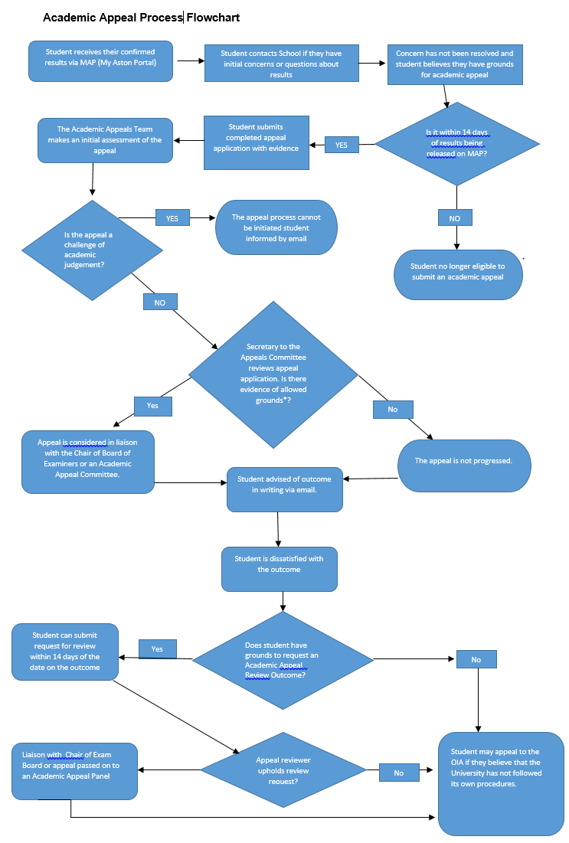

If you are unsure about what is meant by academic judgement, please seek advice from the Advice and Representation Centre (ARC) or from the relevant Associate Dean from your School.
The OIA is the ombudsman for English universities. They will review complaints to ensure that the University has acted within its own university regulations and procedures.

